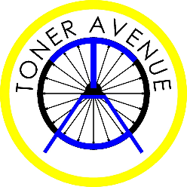
To our amazing Year Six,
Firstly, what an honour it has been to have been your teachers! We’ve enjoyed every precious second that’s been spent with you- watching each of you learn and grow more every day. Every single member of our staff is devastated to be faced with the thought of you leaving us early, we have been dreading the thought of you leaving in July, and to find ourselves in this situation so abruptly has left us all heartbroken.
In the coming weeks we will find ourselves feeling lost & longing for normality, all that we want right now is to be back in our classrooms filled with your bright, smiling faces, and we pray that this will soon be over & we can be reunited with you all soon.
We know many of you are feeling disappointed that you are not able to sit the SATs this year, but please do not ever feel like the hard work that has gone into them has been wasted- you are more than a test score & all the work you have put in will only go on to help you when you are in comp!
Please keep checking the Google Classrooms & contributing to the discussions, you have no idea how proud it makes us to see you all being so resilient while logging on and already completing the work we’re setting you.
We promise to you that this will not be the last time you come to Toner Avenue, regardless of the current situation, when all of this is over we will throw you the biggest and best party where we will sing, dance & celebrate all of your memories & achievements together.
This is not a goodbye – just a ‘see you soon’!
All of the staff at Toner Avenue

