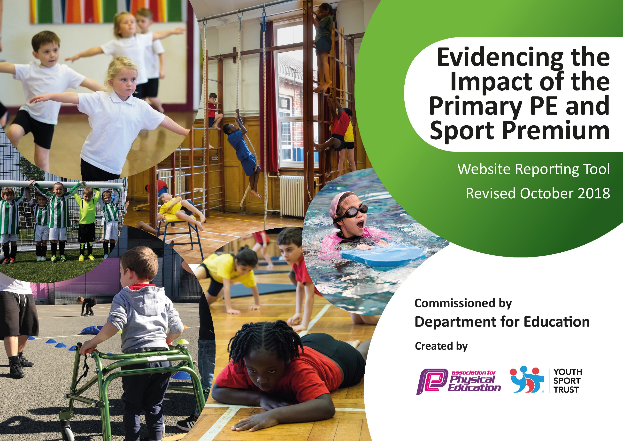
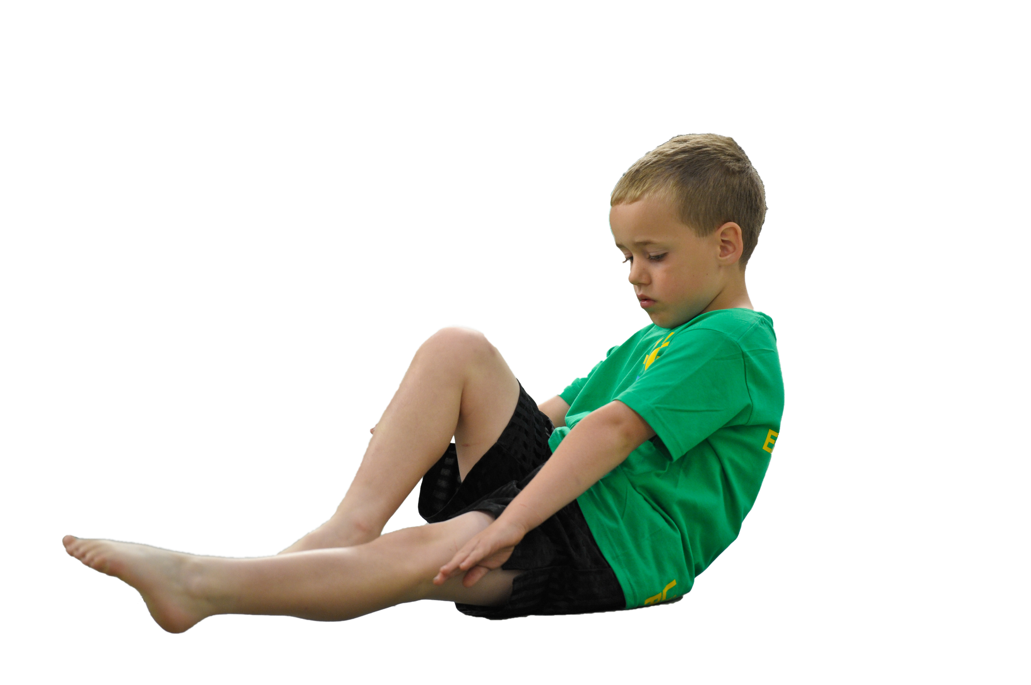
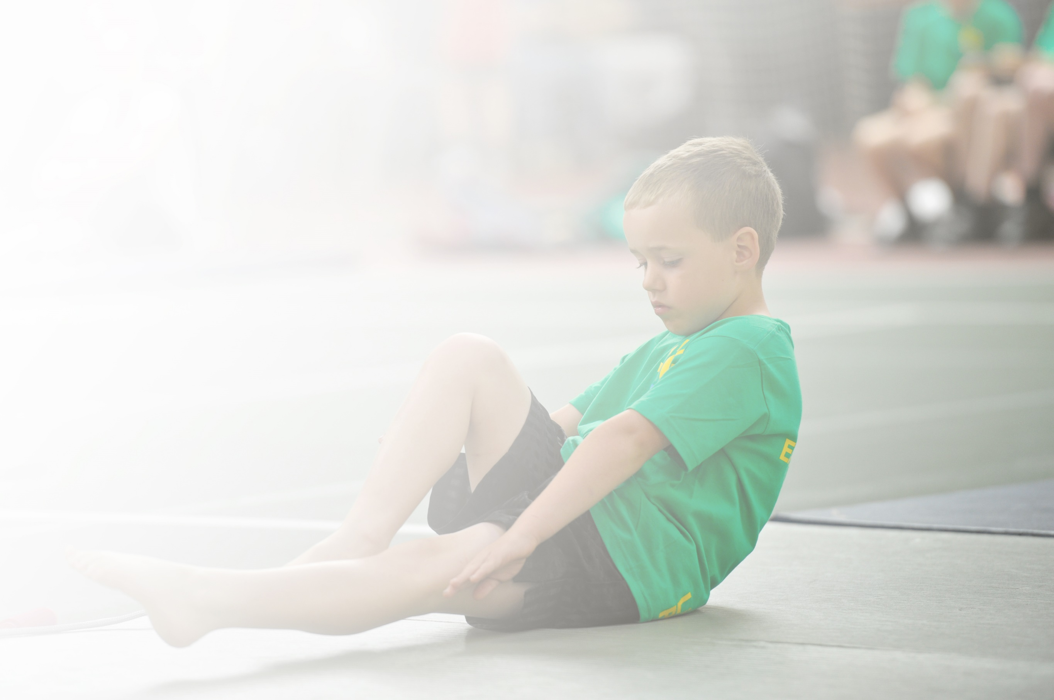
Schools must use the funding to make additional and sustainable improvements to the quality of Physical Education, Sport and Physical Activity (PESPA) they offer. This means that you should use the Primary PE and Sport Premium to:

- Develop or add to the PESPA activities that your school already offer
- Build capacity and capability within the school to ensure that improvements made now will benefit pupils joining the school in future years

Please visit gov.uk for the revised DfE guidance including the 5 key indicators across which schools should demonstrate an improvement. This document will help you to review your provision and to report
your spend. DfE encourages schools to use this template as an effective way of meeting the reporting requirements of the Primary PE and Sport Premium.

We recommend you start by reflecting on the impact of current provision and reviewing the previous
spend. Under the Ofsted Schools Inspection Framework, inspectors will assess how effectively leaders use the Primary PE and Sport Premium and measure its impact on outcomes for pupils, and how effectively governors hold them to account for this.

Schools are required to publish details of how they spend this funding as well as on the impact it has on pupils’ PE and sport participation and attainment by the end of the summer term or by 31 July 2019 at the
latest.
We recommend regularly updating the table and publishing it
on your website throughout the year, as evidence of your
ongoing review into how you are using the money to
secure maximum, sustainable impact. To see an
example of how to complete the table please
click HERE.

Support for review and reflection - considering the 5 key indicators from DfE, what development needs are a priority for your setting and your students now and why? Use the space below to reflect on previous spend, identify current need and priorities for the future.

Key achievements to date: | Areas for further improvement and baseline evidence of need:
- Use of high quality coaches to help upskill staff in teaching high quality lessons.  - Replenish resources.  - Increasing participation in Inter-School competition.  - Increased percentage of Y6 children meeting national requirement for swimming in 2018/19.  - Introducing children to a wide range of sporting activities. | - New Scheme of Work for teaching P.E.  - Assessment of P.E.  - Resources for new school.  - Enhance outside area for P.E. opportunities.

Meeting national curriculum requirements for swimming and water safety | Please complete all of the below:
What percentage of your current Year 6 cohort swim competently, confidently and proficiently over a distance of at least 25 metres?  N.B. Even though your children may swim in another year please report on their attainment on leaving  primary school. | 74% during curriculum swimming  91% after additional lessons paid for by Sports Premium
What percentage of your current Year 6 cohort use a range of strokes effectively [for example, front crawl, backstroke and breaststroke]? | 35%
What percentage of your current Year 6 cohort perform safe self-rescue in different water-based situations? | 81%
Schools can choose to use the Primary PE and Sport Premium to provide additional provision for swimming but this must be for activity over and above the national curriculum requirements. Have you used it in this way? | Yes

Action Plan and Budget Tracking
Capture your intended annual spend against the 5 key indicators. Clarify the success criteria and evidence of impact that you intend to measure to evaluate for students today and for the future.

Academic Year: 2019/20 | Total fund allocated: £18340 | Date Updated: September 2019
Key indicator 1: The engagement of all pupils in regular physical activity – Chief Medical Officer guidelines recommend that primary school children undertake at least 30 minutes of physical activity a day in school |  |  |  | Percentage of total allocation:
 |  |  |  | 15%
School focus with clarity on intended impact on pupils: | Actions to achieve: | Funding allocated: | Evidence and impact: | Sustainability and suggested next steps:
- To offer a comprehensive and wide ranging extra-curricular programme. This could be recreational or competitive.  - To continue to develop an active playground.  - To increase opportunities of children to be active. | - Increase number of sporting clubs at school.  - Source high quality coaches.  - Promote clubs of interest to children.  - CPD for staff to encourage pupils to be active at playtimes and lunchtimes.  - Resources for active playtimes.  - Develop activity breaks within the classroom by subscribing to Jump Start Jonny. | £1500 on top of parent contributions.  Part of SLA  £1000  £259 | - More children active for 30 minutes at school.  - Registers of pupils attending extra-curricular clubs.  - More active children during playtimes and lunchtimes.  - Improved behaviour during lunchtimes and playtimes.  - Staff more involved in encouraging and involving children in activities.  - Children will be provided with the opportunity to stay active within the classroom during the school day. | Develop links with sports clubs/coaches to signpost children to outside providers.  Children will notice the positive impact of exercise on their body and learning and consequently take more responsibility in the future for their physical and mental health.

Key indicator 2: The profile of PESSPA being raised across the school as a tool for whole school improvement |  |  |  | Percentage of total allocation:
 |  |  |  | 8%
School focus with clarity on intended impact on pupils: | Actions to achieve: | Funding allocated: | Evidence and impact: | Sustainability and suggested next steps:
- Promote sport and P.E. and healthy lifestyles within the school. | - Keep an up to date notice board of activities and achievements of pupils within school.  - Liaise with external providers to relay benefits of sport and healthy lifestyle.  (Durham Cricket Club, British Judo Newcastle , etc) | £1500 | Children are proud to share their achievements. Encourage others to achieve.  ‘Power of the Badge’ inspires children to try harder. | Children have their future sporting aspirations raised alongside their self-belief. They are encouraged to dream and be ambitious.

Key indicator 3: Increased confidence, knowledge and skills of all staff in teaching PE and sport |  |  |  | Percentage of total allocation:
 |  |  |  | 55%
School focus with clarity on intended  impact on pupils: | Actions to achieve: | Funding  allocated: | Evidence and impact: | Sustainability and suggested  next steps:
- Improve resources and planning of high quality lessons. | - Purchase new scheme of work to help non-specialist teach high quality lessons.  - CPD of all staff.  - Replenish Resources  - High quality specialist coaches to upskill staff. | £3000  £2000  £5000 | - Higher engagement of pupils in lessons.  - Pupils challenging themselves to do their best.  - Staff more confident in delivery high quality lessons. | New scheme of work to ensure high quality teaching of lessons, building on core strengths year after year.

Key indicator 4: Broader experience of a range of sports and activities offered to all pupils |  |  |  | Percentage of total allocation:
 |  |  |  | 4%
School focus with clarity on intended  impact on pupils: | Actions to achieve: | Funding  allocated: | Evidence and impact: | Sustainability and suggested  next steps:
- Continue to offer a wider range of activities both within and outside the curriculum in order to get more pupils involved. | - Continue to participate in sporting competitions and physical activity experiences supplied by South Tyneside Sports Partnership and School Games.  - Network and source quality outside providers to introduce new after school clubs.  - Arrange a pupil survey to ascertain what pupils would like.  - Introduce new sports/events with stimulating launch events. Hoopstarz, skipping festivals. | Part of SLA  Free  £800 | - After school provision of a high quality and broad in the range of clubs we offer. This is continually reviewed and refreshed depending on pupil interests.  - More children joining extra-curricular clubs. | Develop strong links with quality providers for after school clubs.  Children then have avenues outside of school to develop their further interest.

Key indicator 5: Increased participation in competitive sport |  |  |  | Percentage of total allocation:
 |  |  |  | 26%
School focus with clarity on intended  impact on pupils: | Actions to achieve: | Funding  allocated: | Evidence and impact: | Sustainability and suggested  next steps:
- Attend more inter school competition within South Tyneside. | - Join South Tyneside SLA  - Transport to competition | £2700  £2000 | Greater percentage of children attending/competing in Level 2 festivals and competitions. | Will need to allocate budget for this in future years if Sports Premium Funding ceases in July 2020.

