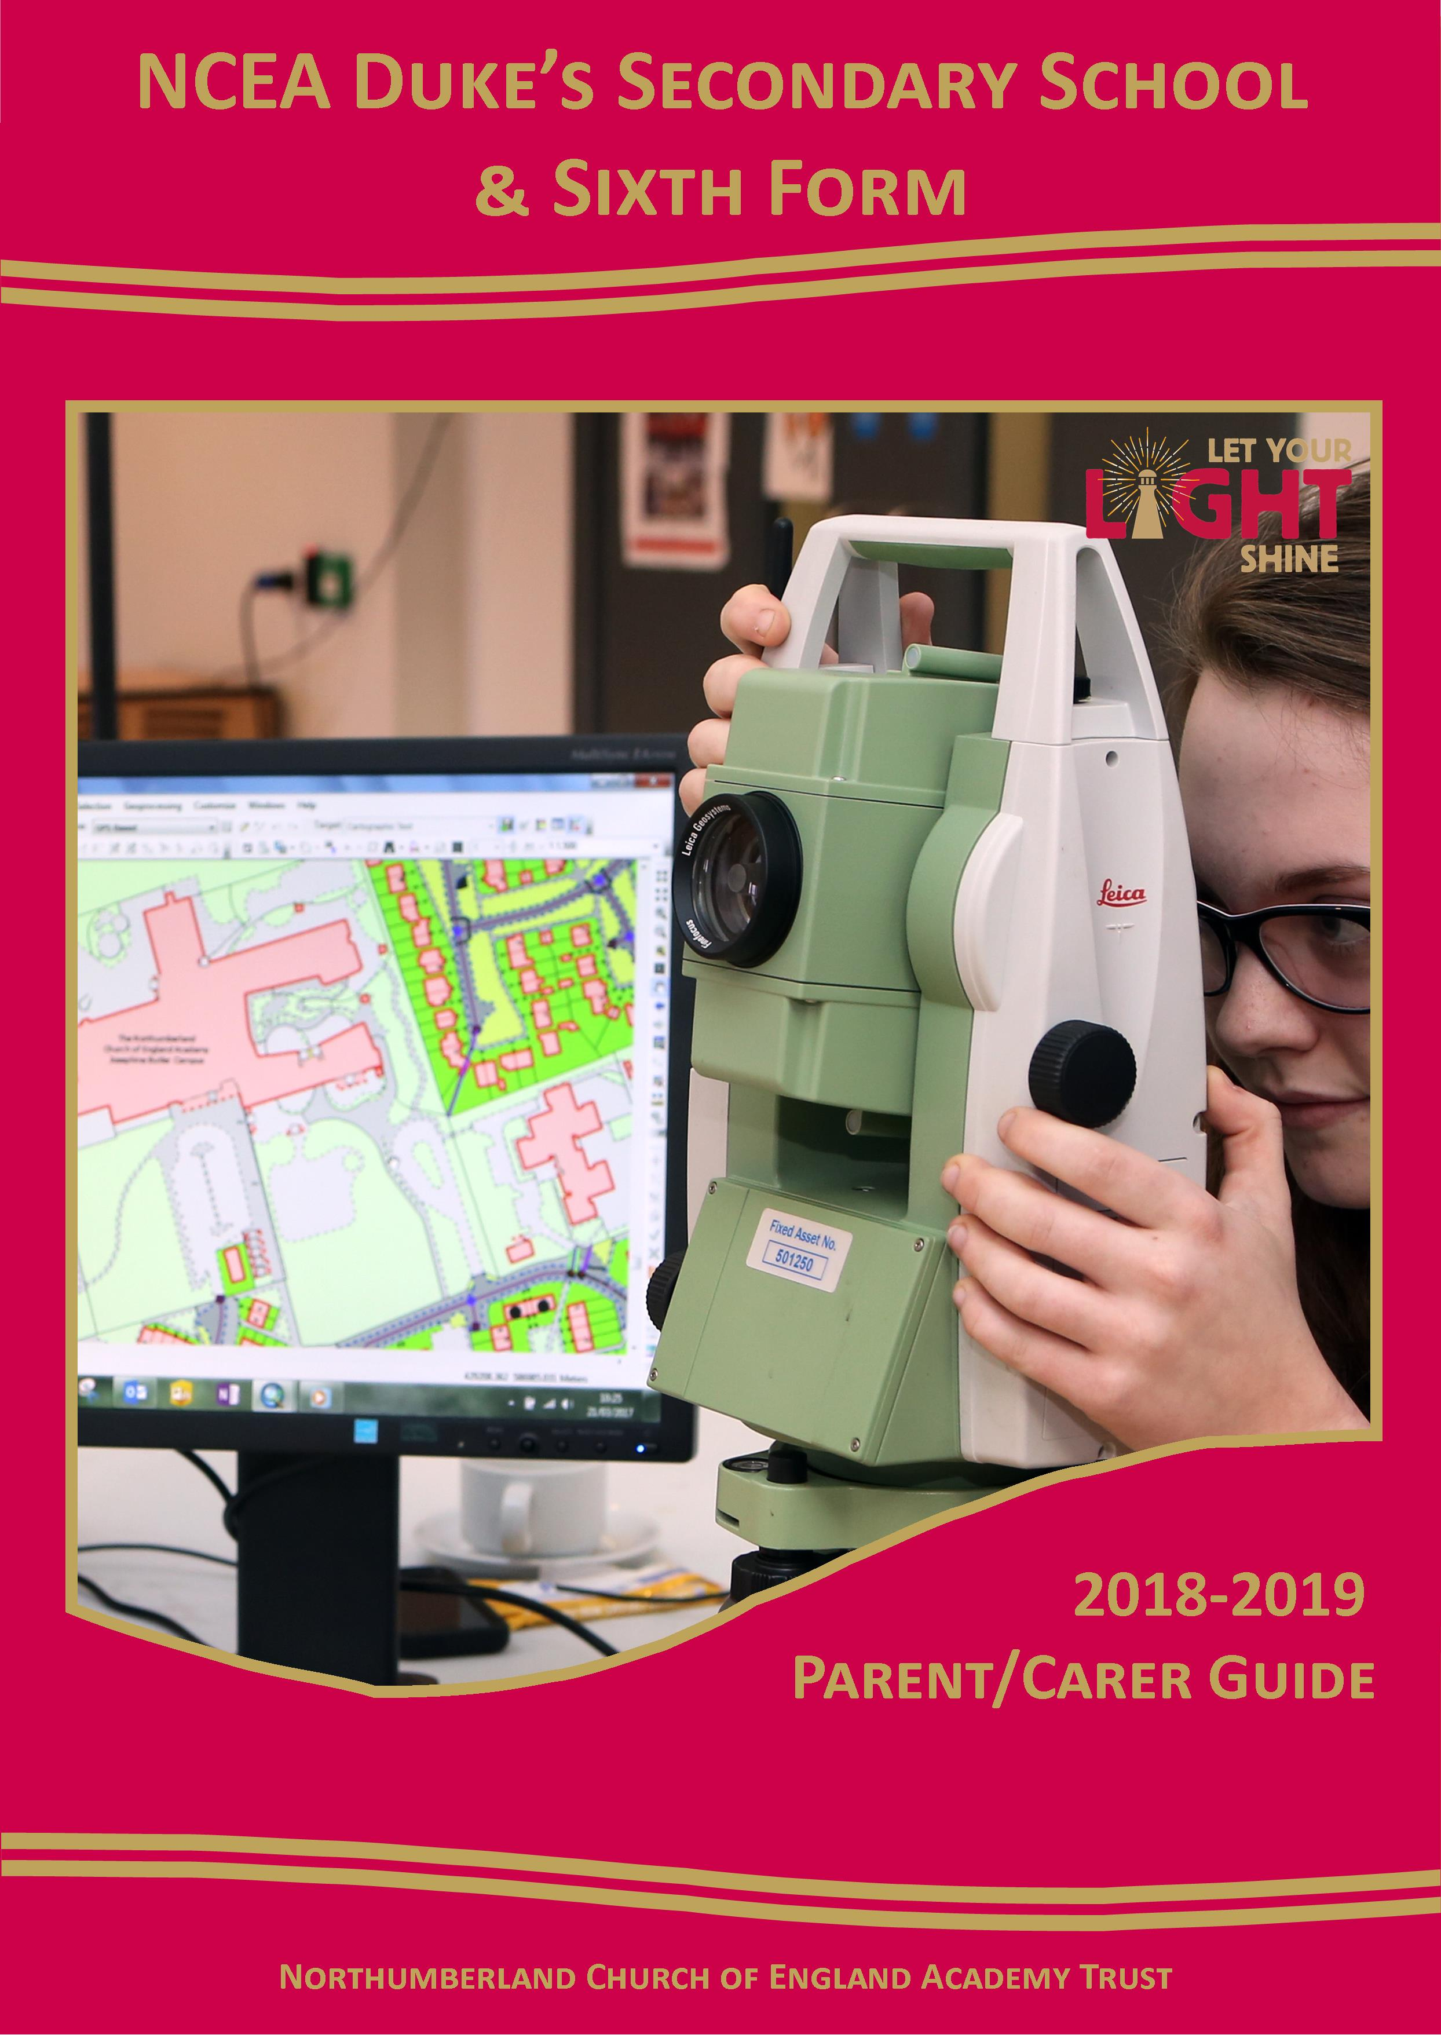

# 

# **Welcome to Duke’s Secondary School**

Welcome from the Principal 3

Key Staff and School Contact Details 4

Our Expectations 6

Attendance and Punctuality 7

Buses 9

Behaviour for Learning 9

Cashless Catering 10  
 Class Charts 10

Combined Cadet Force (CCF) 11

Equipment 11  
 5 Minute Walk Plan 12

Hair 12

Holidays 13

Homework 13  
 House System 13

Jewellery 14

Learner Welfare 14

Lockers 14

Make-up 14

Medicines 15

Mobile Phones 15

PE Kit and Participation 15

Policies 15  
 Telephone Contact 16

Term Dates 2018/19 16

Times of the Academic Day 17

Toilets 17

Trips and Visits 17  
 Water 17

Uniform 18

Worry Wall 20



Welcome

All at NCEA Duke’s Secondary School and Sixth Form look forward to welcoming pupils into the new academic year. Information provided in this document should help to answer any questions you may have before the year commences.

Throughout your child’s time at school we will often talk about the five key values that the school holds dear. In Matthew chapter 5 we read the following: “Let your light shine so that others may see the good things that you do and give glory to God in heaven.” It is this passage from the Bible that has inspired us to think about light, and how we all let our light shine in everything that we do. We remember the word LIGHT through our five key values:

Love

Inclusivity

Goodness  
 Hope

Truth

These are the key values by which we make our decisions in this school, and the ways in which we encourage our pupils to learn and develop as they grow into young adults. There is a light shining in each child who comes into the school, and we want to help fan that flame into a bright shining light! We look forward to helping you to let your LIGHT shine at Duke’s School!

With best wishes,

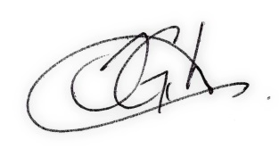

**Mr S G Gibson  
Principal**

# Duke’s Secondary School & Sixth Form Northumberland Church of England Academy Trust

|  |  |
| --- | --- |
| **ADDRESS** | **TELEPHONE** |
| NCEA Duke’s Secondary School & Sixth Form  Academy Road  Ashington  NE63 9FZ | 01670 816 111 |
| **WEBSITE** |
| www.ncea.org.uk/secondary |
| **EMAIL** |
| admin.dss@ncea.org.uk |

|  |  |  |  |  |  |
| --- | --- | --- | --- | --- | --- |
| **Senior Leadership Team** | | | | | |
|  | |  | |  | |
| **Mr Gibson** Principal | | **Mr Atkinson** Deputy Principal | | **Mr Line**  Vice Principal | |
|  |  | |  | |  |
| **Mrs Gadsby** Assistant Principal | **Mr Rhodes** Assistant Principal | | **Mrs Chima**  Associate Leader | | **Mr Smith**  Associate Leader |

|  |  |  |  |  |  |  |  |
| --- | --- | --- | --- | --- | --- | --- | --- |
| **Key Stage Team** | | | | | | | |
|  | | | |  | | | |
| **Mr Waterston** Head of Key Stage 3 | | | | **Mr S Barber**  Head of Key Stage 4 | | | |
|  |  | |  | |  | |  |
| **Mrs Young** KS3 Learning & Progress Manager  (Pastoral Link Y7) | **Miss Matthewson**  Behaviour & Intervention Assistant (Pastoral Link Y8) | | **Ms Spratt**  Learning & Progress Support Officer (Pastoral Link Y9) | | **Miss Ireland**  Behaviour & Intervention Assistant (Pastoral Link Y10) | | **Miss D Graham**  KS4 Learning and Progress Manager  (Pastoral Link Y11) |
| **Achievement Staff** | | | | | | | |
|  | |  | |  | |  | |
| **Mrs Collin** Special Educational Needs Coordinator | | **Mrs Towers** Head of Sixth Form | | **Mr Fox**  Careers, Enterprise & Employability Manager | | **Sally Milner**  Chaplain | |

|  |  |  |
| --- | --- | --- |
| **Academic Leaders** | | |
|  |  |  |
| **Mr Thompson** Director of Creative Arts | **Miss Wardle** Asst Director of English | **Mrs Carter**  Head of Humanities |
|  |  |  |
| **Miss Hart** Head of ICT & Computing | **Mr Butler** Director of Maths | **Mr Shaw**  Head of Modern Foreign Languages |
|  |  |  |
| **Mrs Freeman**  Head of Tutorial and PSHCE | **Mr Blight** Director of Sport | **Mr Rowe** Head of Religious Studies |
|  |  |  |
| **Ms Fletcher**  Head of Science | **Mrs Barker** Head of Vocational Studies | **Miss North**  Head of Alternative Provision Curriculum |

# Our Expectations

We have three golden rules at Duke’s School. These are our “Three Ps”, and all pupils should strive to achieve these expectations every day at school.

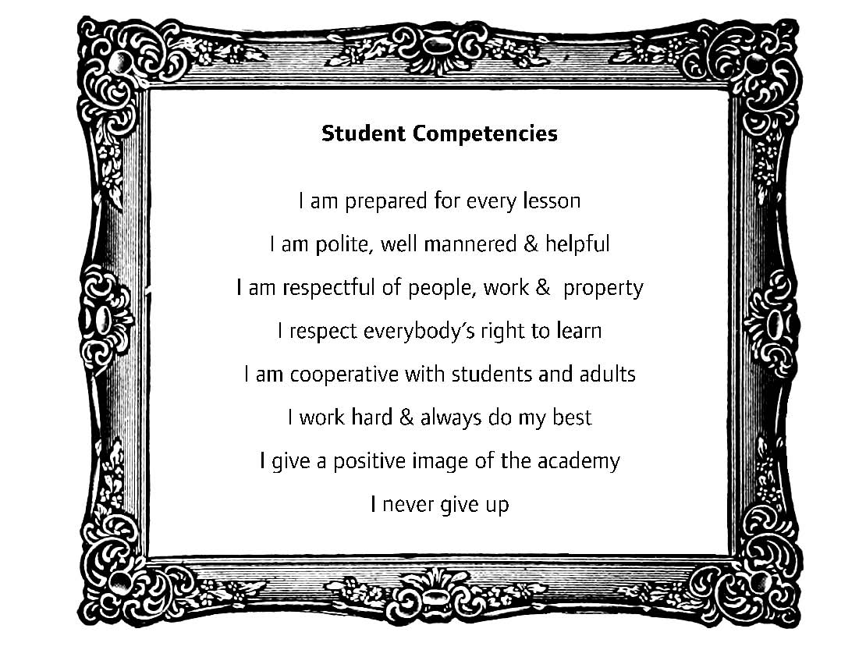

Be prepared

Be polite

Persevere

Being prepared involves all of the different ways that we need to be ready to learn at school, including having the right uniform, the correct equipment, having our planner signed at home, completing homework, listening in lessons etc.

Being polite is an expectation in all our interactions, with other pupils, with staff, with visitors, and making sure that our choice of words is kind and appropriate. Being polite includes showing respect to others, to the building, and to our neighbours. Being polite includes ensuring our behaviour does not impact negatively on any other person.

Persevering means to keep going! To try, and keep trying. To not give up. This could be on a small scale with an activity in a lesson, or the more long term perseverance to keep trying all the way through the school.

# Attendance

Your child’s attendance at school is vital to their success. As a parent/carer you also have a legal duty to ensure that your child(ren) attends school. Our Attendance Strategy sets out clearly our expectations in this vital area, and the consequences for those who do not meet the requirements. These consequences may involve referrals to the Education Welfare Service within Northumberland County Council which could result in the issue of fines, prosecution or both.

**Your child’s target for attendance is 100%.**

**However, your child will become a cause for concern to the school if their attendance   
falls below 96%, the equivalent to 5 days absence during the school year.**

If your child is going to be late or absent from school, please make sure you contact us on 01670 816 111 or   
e-mail: [learnerwelfare@ncea.org.uk](mailto:learnerwelfare@ncea.org.uk).

A detailed copy of this strategy is available on our website.   
**Medical/dental appointments should not be made in school time.**

|  |  |  |
| --- | --- | --- |
| **Missing out misconceptions!** | | |
|  |  |  |
| **“It’s only one week – he can catch up.”** | **“It’s not like she’s going to miss out on anything.”** | **“It’s the only time I can take him shopping. It’s only one day.”** |

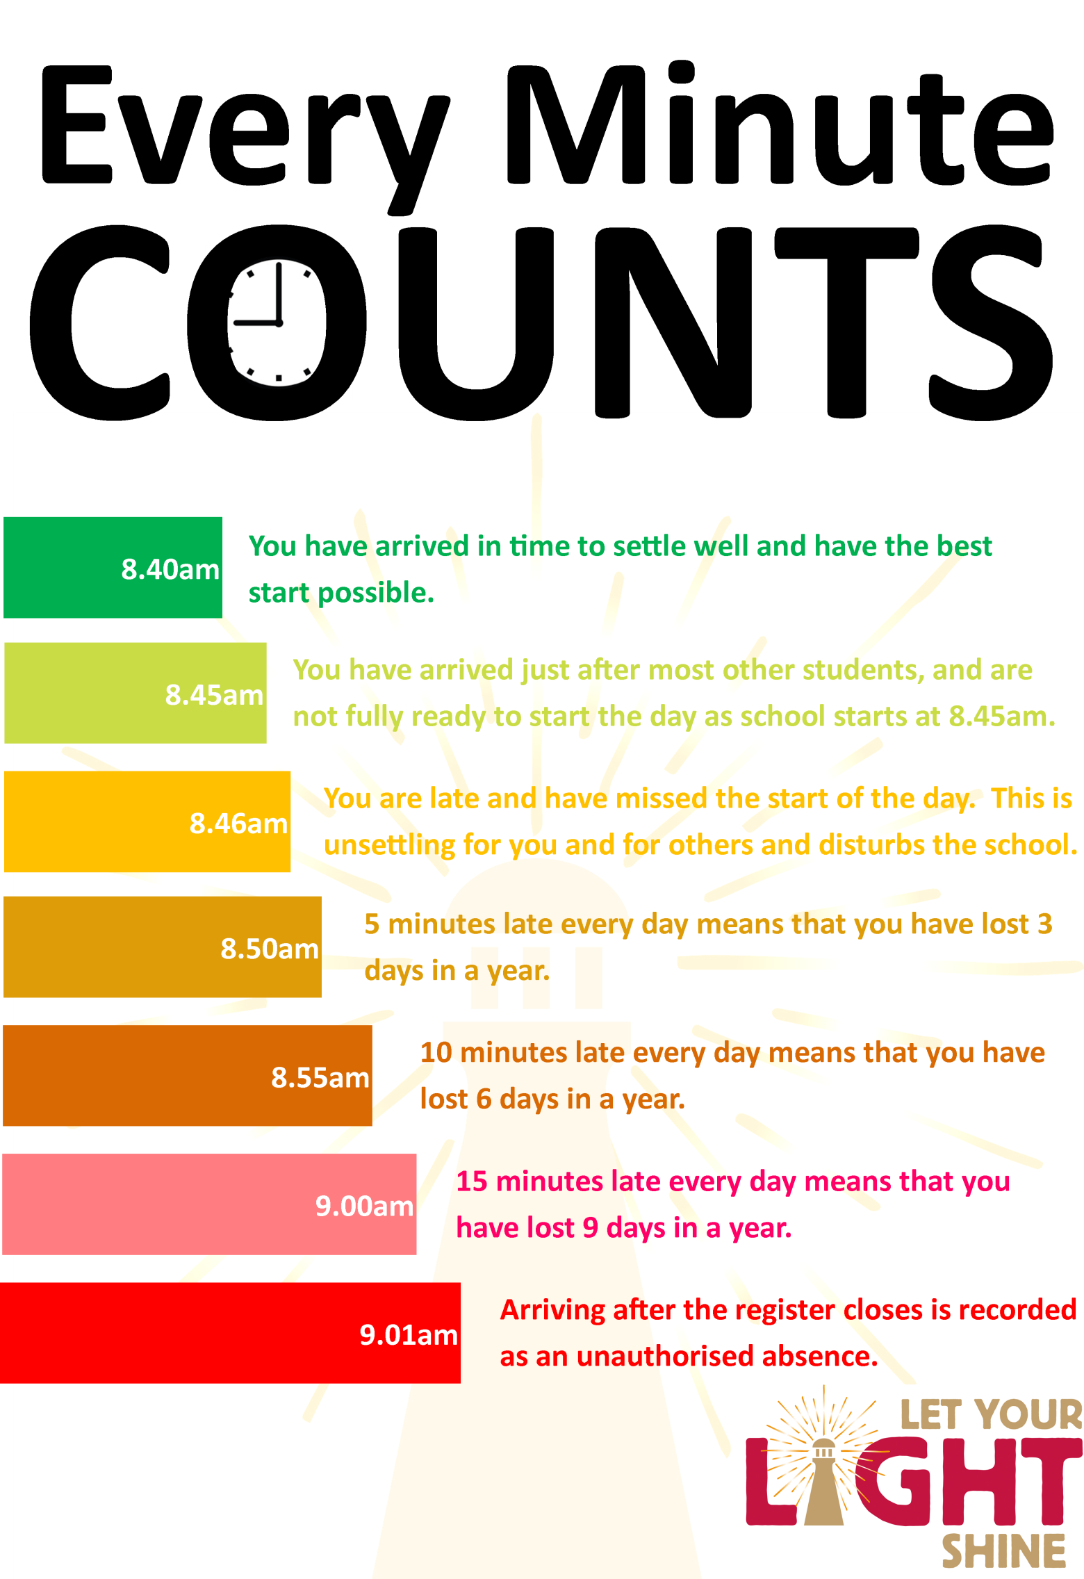

# Buses

Information regarding public transport and the County Council is subject to change without our knowledge, therefore, the following information is correct at the current time but individual parents/carers should check directly with the bus company or council for final information.

Subsidised travel can be applied for through Northumberland County Council if you live in Lynemouth or Newbiggin. Arriva offers parents and pupils a more affordable way to pay for bus travel through their Arriva Student Direct Debit Scheme. This allows payments to be spread monthly for an academic year ticket. The ticket includes travel during term time, half term, weekends and evenings, giving more value for money. If you do not qualify for subsidised travel then this scheme could be ideal for you. For more information please go to [arrivabus.co.uk/studentsne](http://arrivabus.co.uk/studentsne)**.** Pupils who arrive at school on the Lynemouth or Newbiggin buses are expected to come straight into the school building once they leave the bus and not to go off site.

Those pupils using the Lynemouth or Newbiggin buses should also recognise that school expectations cover their journey on those buses, and that any incidents of behaviour which are below our expectations will be dealt with using the Behaviour for Learning process.

# Behaviour for Learning

We expect that all pupils will follow our Code of Conduct and will show that they possess the Student Competencies that go towards making a great learner. Some pupils, however, may choose not to follow the expectations of the school, and a series of sanctions are in place as a consequence for choosing behaviours which prevent our lights from shining.

We believe that a detention has more of an impact if carried out on the day of the incident. In order to do this all reasonable attempts to contact parent/carers will be made using telephone calls and texts home in order to speed up the process. We ask that parent/carers ensure that all contact numbers held by the school are current and updated when they change.

“Late Detentions” will be issued to pupils who arrive late without a reasonable explanation.

Detentions can be set for morning, break, dinner, after school or on a Saturday. This will vary depending on the severity of the incident.

Although parental consent is not required for detentions to be issued, the school will make every effort to contact parents/carers if an after school detention is issued. Our policies for behaviour comply with the Department for Education’s advice for schools:

‘*parental consent is not a requirement for any school to keep a child in detention’*

It is the responsibility of the parent/carer to put provisions in place for collecting a pupil after a detention.

If you have any concerns about the detention, please contact the Key Stage Team or the teacher who gave the detention.

If a pupil is involved in a serious incident, or a series of incidents, they may receive a Fixed-Term Exclusion. This is a very serious sanction, and is only applied for serious or continuous breaches of school expectations. If a child is excluded from school they are not able to attend school again until the reintegration meeting has taken place, and a behaviour contract will be issued. During the time of an exclusion the child must not be present in public places, and is the responsibility of the parent/carer to supervise.

# Cashless Catering

Our canteen is a cash free zone. There are cash points throughout the building where pupils can credit money on to their account. These machines **do not** give change so if a note is given all of it must be placed onto the pupil account. Pupils can check any machine to see how much money they have left on their account during morning, break and lunch times. It is their responsibility to make sure they have enough credit to pay for their meals.

Lunch costs around £2.30 for a main meal and dessert or a main meal and a drink. Pupils are also able to buy drinks and snacks at break time. For this, extra credit will be required. For pupils who are entitled to free school meals, £2.30 per day will automatically be credited to their account. They can add extra credit to this to use at break time for snacks and drinks if they wish by bringing in money and using the revaluation stations.

It is important that pupils do not go into debt as if they have no money they will not be able to purchase any food. If a pupil forgets to bring money in for their dinner or does not have enough credit, every effort will be made to contact the parent/carer to ask for money to be brought in.

# Image result for classcharts

ClassCharts is our online system which teachers and support staff use to track achievement and behaviour throughout the school day. We believe in working closely with parents/carers and one of the key benefits of using Class Charts is that we are able to securely share your child’s achievement and behaviour report with you electronically and so keep you up to date in real-time.

Each child has a unique access code which we will issue to parents/carers. Once you have been issued with a code you will need to create an account and enter the code here: *https://www.classcharts.com/parent/login*

You can also find links to mobile phone apps for parents/carers from this page or in the Apple store or Google Play store. If you have more than one child in the school then you can enter additional codes once you have created an account and are logged in.

This gives you the opportunity to praise or sanction your child as you see fit based upon their performance in school. We realise that having access to more information about your child’s behaviour may well lead you to having more questions or concerns about why or what has happened for your child to receive achievement or behaviour awards. However, it is important to remember that school staff deal with these matters on a daily basis and only rarely would the incident require us to contact parents/carers. If we have concerns about your child, a member of the relevant Key Stage Team will contact you as usual and we would encourage you to try to only contact the school if the behaviour event is of a serious nature.

**Top Tips for using Class Charts**

* Praise your child when they have been awarded positive points! It is important to reinforce the good things that pupils do each day.
* Try to use the reported behaviour as a discussion point with your child. If you are concerned about your child’s behaviour, try setting positive targets for them to achieve. If you are still concerned you can, of course, contact the school and make an appointment to speak to a member of the Key Stage Team.
* The teacher reporting the behaviour is doing so as a professional who is present at that moment. We trust our staff to make accurate and professional decisions, and so we ask you to also trust us. Try not to challenge the school concerning reported behaviour where a child may have a different version of events, but discuss with your child and try to help them to understand how their behaviour impacts on others.
* Be patient with yourself! Using the information in Class Charts may raise concerns or questions, but the more you use it, the clearer it will become. If your questions remain after a few weeks, contact the school at that point for some support.

# Combined Cadet Force

We have an active CCF who have operated from our Robert Stephenson Campus since September 2013. This provides great opportunities for young people in Year 8 and above to join the contingent, which is affiliated to the Coldstream Guards. The CCF is a voluntary organisation, sponsored by the Ministry of Defence, and established in over 300 schools in the UK, giving cadets access to a wide range of activities organised by qualified instructors, regular soldiers and reserves.

Cadets follow a set syllabus that will see them develop in their leadership, confidence and reliability, and will get to take part in a wide range of activities encompassing basic aspects of army training, marching, first aid, field craft, weapons training, map reading and methods of instruction. When the Cadet is 13 yrs 9 mths, they will be able to enrol on to the Duke of Edinburgh’s Award.

Pupils wishing to join, or find out more, should come to the Atrium on Thursdays at 3.20pm. They will be given an introduction and an application form which must be completed by parents/carers. Further information is available on our website, or from CCF members or staff.

# Equipment

Pupils should have a bag for their work, **a pen, pencil, ruler**, **rubber**, PE equipment and a clear water bottle. A **planner** is provided by the school when pupils arrive in September. We have a stationery stall at school where pupils can purchase essentials at no profit.

The planner is the most important tool for communicating between home and school. The planner will be used for:

* Recording successes and praise
* Recording instances of poor behaviour
* Pupils recording their homework
* Provide an opportunity to communicate between teachers and parents/carers
* Recording health issues experienced either at home or in school
* Used to pass a message on from pastoral staff to teaching staff
* Recording specific events that are happening in the school
* Tracking and monitoring attendance and target setting
* Recording reading
* Reviewing progress
* Tracking attendance

Planners are checked every week by Form Tutors to ensure they are being used properly. Pupils must have their planners with them at all times, otherwise sanctions may be applied. Planners should be placed on the desks during lessons. If a pupil loses his/her planner they will have to buy a new one at a cost of £5.00. This is essential equipment.

# 5-Minute Walk Plan

To encourage our pupils to have at least 5 minutes of exercise each morning, and to help us as a school to be good neighbours to those who live near the campus, we ask that parents/carers should arrange to drop-off and collect pupils anywhere on the green routes shown on the “5 Minute Walk” map below. Any point on the green route takes no more than 5 minutes to walk to the pupil entrance, and the dashed green lines show some of the many potential walking routes onto campus. The roads in red are part of our “Good Neighbour Traffic Exclusion Zone”, and we would encourage parents/carers not to drive onto the red roads within 30 minutes before or after school arrival and departure times. This allows the roads to be kept free for approved transport of pupils with disabilities, and for county buses.

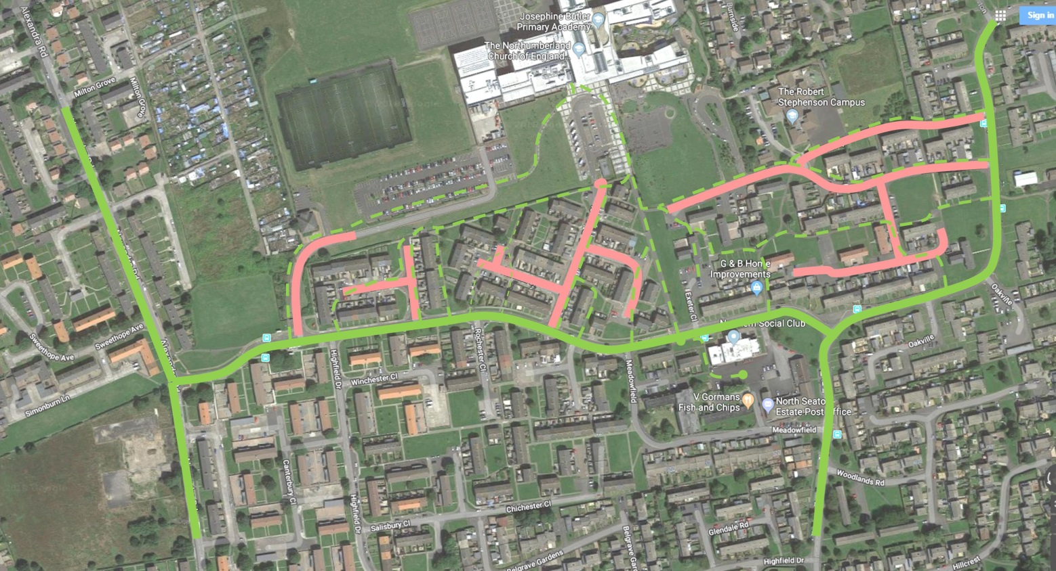

# Hair

Extreme hair styles are not permitted in school. This includes designs shaved into heads or partially shaved heads. Outrageous colours such as bright pink, green, blue, red, dipped ends or under colours will not be accepted. Only natural colours will be permitted. Hair accessories should be neutral in colour.

Pupils who come into school with such hair colours will be asked to dye their hair back to an appropriate colour. Sanctions will be put into place and parent/carers contacted for those pupils who come into school with partially shaved heads. As with any other rule, if a pupil continuously refuses to follow the expectations of the school they may be placed into the Learning Reflection Classroom (LRC) to work away from the rest of the school community until the issue is resolved.

# Holidays

Pupils should not be taken out of school for holidays during term time as it has a detrimental effect on their education, and can severely disrupt their progress and impact on their attainment levels. This not only affects the pupil who is absent, but impacts on the rest of the class as the staff have to provide extra support to bridge the knowledge gap. Leave of absence will only be granted in exceptional circumstances, and forms to request this can be collected from Reception or the Admin Team and should be completed and returned to the school admin team.

# Homework

Information on homework can be found in the pupil planner and will be set online using *Doddle*. All pupils and parents will have access to *Doddle* to complete, check and monitor homework. Homework is a part of school life and we expect pupils to complete their homework on time. Sanctions for pupils who do not complete homework, such as after school detentions, will be given.

Homework club takes place every Wednesday from 2.30pm to 3.20pm.

# House System

All pupils are placed into a “house” throughout their time at school. This house is the basis for the tutor group, internal competitions, sports day and many other activities. In normal circumstances, pupils in Years 7 to 10 will stay within the same house tutor group throughout their time at the school. They are placed into different groups for their subject lessons, which are based around academic ability demonstrated in their Key Stage 2 outcomes. During this academic year, Year 11 will continue in academic tutor groups.

We have four houses:

|  |  |  |  |
| --- | --- | --- | --- |
|  |  |  |  |
| **Aidan House** | **Cuthbert House** | **Hild House** | **Oswald House** |

Positive points that are achieved in lessons will go towards the house total, along with other house points awards throughout the year.

# Jewellery

Pupils are allowed to wear one pair of stud earrings in their ear lobes. No other jewellery is allowed apart from a watch. Pupils wearing other jewellery will be asked to remove it for collection at the end of the school day. This includes, but is not limited to, ear expanders, spiked earrings, dangling earrings, nose studs or rings, lip studs or rings, eyebrow studs or rings, bracelets, necklaces and rings. These items can pose a health and safety risk during the school day. Most pupils comply with this request, but for those who have to be asked to remove these items regularly then the jewellery will be confiscated and a parent/carer will need to come in and collect the item(s). Staff will check pupils at the beginning of the school day to ensure that they have come to school appropriately.

# Learner Welfare

Across the schools within the NCEA Trust, we aim to create learning environments where pupils feel secure, valued and are encouraged to talk in the knowledge that they will be listened to. We have a number of staff who have roles dedicated to ensuring that children are safe and those who are able to support in a range of different ways. We also work in partnership with the NHS, CYPS, and other agencies to support our young people where those can not be met by the school.

Within Duke’s Secondary School & Sixth Form we have two Designated Safeguarding Leads, and two Deputy Designated Leads. Any concerns should be reported to either **Mrs Gadsby** or **Mr Line** in the first instance, or if unavailable, to Mrs Young or Miss Graham. Parents/Carers can reach these staff via the switchboard on 01670 816 111.

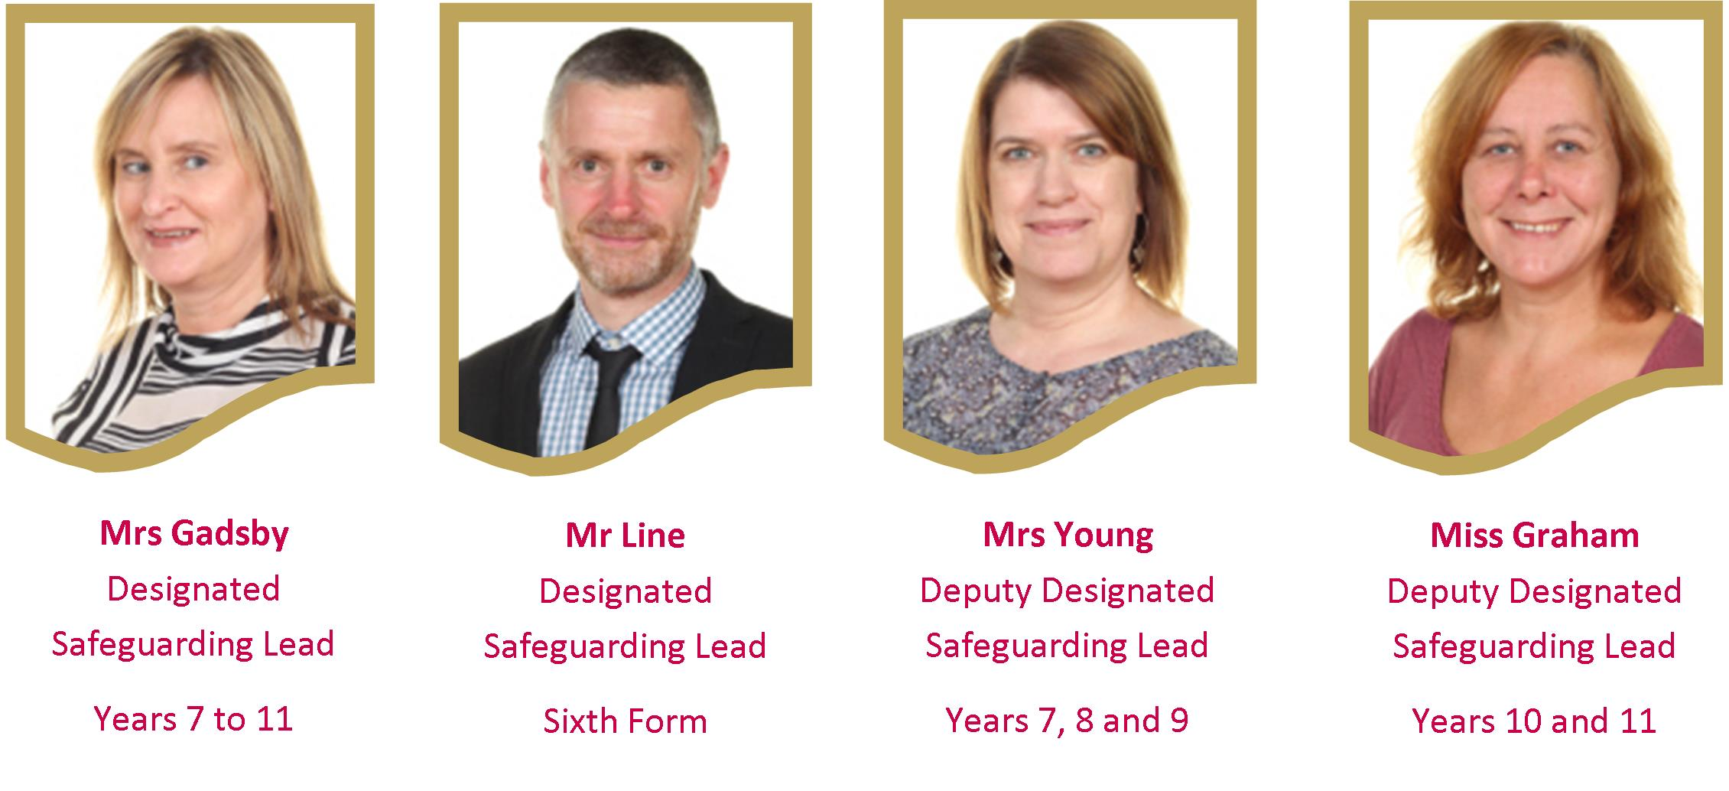

# Lockers

Every pupil has access to a locker. The school has combination padlocks which the pupils can loan for a £5.00 deposit. Pupils will receive a refund for the padlock when it is returned. This may be at the end of their time at school or when they feel they no longer need to use it. Please note that pupils cannot bring their own padlocks into school.

# Makeup

It is NCEAT policy that pupils are not allowed to wear make-up. If pupils come into school wearing make-up, they will be asked to remove it with wet wipes and/or sensitive eye make-up remover, provided by staff. This includes, but is not limited to, foundation, eye shadow, mascara, eye liner, lip gloss or lipstick, rouge/blusher and eyelash extensions or false eyelashes. Nail varnish and false nails are also not acceptable. Pupils will be provided with nail varnish remover and/or acetone to remove these.

Where a pupil regularly does not comply with this requirement, letters will be sent home and further sanctions may be put in place. We reserve the right to check bags and remove make-up to be collected by a parent/carer.

# Medicines

The Trust has a strict policy regarding medicines:

* **No medicine is allowed in the school** unless an appropriate agreement to administer medicine form has been completed and approved by the Principal. Forms are available from Reception.
* All medicines are kept in a locked cabinet in an Admin Office. If prescribed medicine, we only accept medicine in its original container with the pharmacy sticker attached, showing pupil’s name, dosage etc.
* Pupils who keep medicine in school need to bring a drink with them to take their medicine.
* Any pupil found in possession of medication on them will have it taken off them. This is for the safety of all our pupils.

# Mobile phones

Mobile phones are an accepted part of daily life, and many parents/carers like to ensure their child is contactable on the way to or from school. We accept that pupils will carry mobile phones to and from school, but these are not permitted to be switched on or used at all during the school day. If a member of staff sees or hears a mobile phone it will be confiscated and the pupil will be required to collect this from Reception at the end of the day. If this becomes a persistent problem for an individual, their phone will be confiscated and this will only be released to a parent/carer from Reception at the end of the school day.

There is a specific requirement for pupils to hand-in their mobile phone when going in to an exam room. It is an exam regulation that if a pupil takes a phone into an exam, whether switched on or not, that the school has to report this to the examination board. In this situation it is likely that the pupil will receive zero marks from that examination, or be disqualified completely.

# PE Kit and Participation Policy

Bringing PE kit to PE lessons is a non-negotiable expectation. If a pupil has a medical reason for missing the lesson backed up by a parental note or telephone call they do not need to take part in physical activity. However, they are still expected to change into the required kit so they can fulfil roles such as umpire/coach/timekeeper etc.

If a pupil has a medical condition that prevents them from taking part, they should have a note from home that is passed on to a member of the Key Stage Team. This will be confirmed and alternative arrangements will be made.

The following steps are in place for pupils who fail to bring kit to PE lessons:

1. First time is considered a mistake, verbal reprimand. Pupils are required to borrow kit from the PE Department.
2. Second time pupils are issued with a break time detention, or lunchtime depending. They are required to borrow kit from the PE Department.
3. Third time pupils are issued with an after school detention. Parents are contacted. They are required to borrow kit from the PE Department.
4. If all of the above have no effect, names are passed to the Key Stage Team. Parents are contacted.

If a pupil refuses to borrow kit then they will need to make up the lesson time missed.

# Policies

Academy polices can be viewed on our website: [www.ncea.org.uk](http://www.ncea.org.uk) .

# Telephone Contact

You can contact members of staff at school by telephone on 01670 816 111. However, it is important to note that the majority of staff time is spent with pupils around the building and only rarely are staff available at their desks to take telephone calls during the day. If a parent/carer contacts a member of staff by telephone it is highly likely that the member of staff will be working with pupils at that time, and we would request that a voicemail message is left for the member of staff. Please leave your name, the name of the child you are calling about, a number that you can be contacted on and any details in your message. The member of staff will contact you as quickly as possible, but please be aware that it is possible that this may not be until after the end of the school day. If you need to get a message through more rapidly, please speak to one of our Admin Team who will arrange for your message to be passed to the member of staff as soon as possible.

# Term Dates 2018-2019

|  |  |  |
| --- | --- | --- |
| **HOLIDAY or OCCASION OF CLOSURE** | **DATE ON WHICH SCHOOL WILL CLOSE** | **DATE ON WHICH SCHOOL WILL REASSEMBLE** |
| **TEACHER TRAINING DAY** | **MONDAY 3 SEPTEMBER 2018** | |
| Summer 2017 | Friday 20 July 2018 | Tuesday 4 September 2018 |
| **TEACHER TRAINING DAY** | **FRIDAY 26 OCTOBER 2018** | |
| October Mid-Term 2018 | Thursday 25 October 2018 | Monday 5 November 2018 |
| Christmas/New Year 2018/19 | Friday 21 December 2018 | Monday 7 January 2019 |
| Spring Mid-Term 2019 | Friday 15 February 2019 | Monday 25 February 2019 |
| Easter 2019 | Friday 5 April 2019 | Tuesday 23 April 2019 |
| **MAY DAY BANK HOLIDAY** | **MONDAY 6 MAY 2019** | |
| Summer Mid-Term 2019 | Friday 24 May 2019 | Monday 3 June 2019 |
| **TEACHER TRAINING DAY** | **FRIDAY 24 MAY 2019** | |
| Summer 2019 | Friday 19 July 2019 | Tuesday 3 September 2019 |

# 

# Times of the Academic Day

|  |  |  |  |
| --- | --- | --- | --- |
| **Mon / Tues / Thurs / Fri** | | **Wednesday only** | |
| **LESSON** | **START** | **FINISH** | **START** | **FINISH** |
| **Action bell will sound:** | 8.45 |  | 8.45 |  |
| **Lesson 1** | 8.50 | 9.55 | 8.50 | 9.55 |
| **Lesson 2** | 9.55 | 10.55 | 9.55 | 10.45 |
| **Break** | 10.55 | 11.15 | 10.45 | 11.05 |
| **Lesson 3** | 11.15 | 11.45 | 11.05 | 11.55 |
| **Lesson 4** | 11.45 | 12.45 | 11.55 | 12.45 |
| **Lunch** | 12.45 | 1.20 | 12.45 | 1.15 |
| **Lesson 5** | 1.20 | 2.20 | 1.15 | 1.40 |
| **Lesson 6** | 2.20 | 3.20 | 1.40 | 2.30 |

# Toilets

Toilets are placed around the building. It is expected that pupils will make use of these during break and lunch times only and not during lessons. If pupils are out of lessons just after break or lunchtime they will be asked to go back to lessons without using the toilet. All ground floor female toilets have sanitation bins.

# Trips and Visits

We attempt to provide trips and visits to interesting and exciting places, both in this country and abroad, throughout a pupil’s time in school. These trips are always of educational value, and have an educational content to them. Financial contributions will be required for pupils to take part in trips and visits, but we aim to fundraise regularly to lower the cost for parents/carers where possible.

Excellent standards of behaviour are required from pupils participating in off-site visits, and school will only support pupils to attend these activities if their behaviour is excellent on a normal basis in school. If a child’s behaviour declines before attending a trip, the child may be removed from the trip and no refund of any monies already paid will be returned.

# Water

The school provides pupils with access to water fountains. Pupils can fill a water bottle brought in from home during break or lunchtime. Other drinks are not permitted during lesson time.

# Uniform

# https://i1.wp.com/smartfuse.s3.amazonaws.com/78a87010b269da33cbdcfc15f570af3b/uploads/2016/12/Uniforms-9-264x400.jpg?resize=264%2C400 https://i1.wp.com/smartfuse.s3.amazonaws.com/78a87010b269da33cbdcfc15f570af3b/uploads/2016/12/Uniforms-8-263x400.jpg?resize=263%2C400

We are pleased with how much pride our pupils take in their uniform. As a reminder, our uniform is:

|  |  |
| --- | --- |
| **Years 7 and 8** | **Years 9, 10 and 11** |
| Black V-neck jumper with NCEAT logo | NCEAT blazer with optional black V-neck jumper with NCEAT logo to be worn under the blazer. |
| White shirt including top button | |
| Black smart trousers / skirt. Not denim. No leggings / tight trousers. All trousers must meet the shoe – there should be no gap between socks and trousers. | |
| Skirts must be no higher than two inches from the pupil’s knee | |
| Year 7 / 8 Tie | Year 9 / 10 / 11 Tie |
| Black Socks / Black or flesh coloured tights. | |
| Black leather/leather looking shoes  (Guidance: this means no trainers, no Vans, nothing that has a brand name or logo on it as often these are trainers, plimsolls or boots. The whole shoe should be black including soles.) | |
| **PE KIT** | |
| NCEAT or plain black tracksuit bottoms, leggings or shorts | |
| NCEAT PE t-shirt, black and red with logo | |
| White or black socks | |
| Trainers (no metal studs) | |
| Black NCEAT hoodie which can be bought with initials on it | |
| Bobble for hair | |

Uniform is checked on arrival to school each morning and by staff throughout the day. If pupils choose not to wear appropriate uniform they will be given uniform to wear. As with any other rule, if a pupil refuses to follow school expectations they may be placed into the Learning Reflection Classroom (LRC) to work away from the rest of the school community until the issue is resolved.

We are happy to help advise you before purchasing items of uniform, and would encourage that if you have any questions about buying clothing/footwear please do contact the Key Stage Team as we do not want parent/carers to spend money on something that is not appropriate to wear.

Our clip-on ties are designed to be safe, durable and easy to put on. However, if clip-on ties are damaged, cut or defaced in any way, then the pupil will be required to buy a new one. If top buttons are removed from shirts then pupils will be asked to sew a new one on. If this does not happen then a needle and thread is provided for them to sew a button on during a break, lunch or an after school slot.

Uniform can be ordered online via the website **www.michaelsehgal.co.uk** and delivered to your home address, or by visiting the uniform shop at **Michael Sehgal & Sons Ltd, 28-40 Scotswood Road, Newcastle upon Tyne, NE4 7JB**.

On **Thursdays only**, pupils who are part of the CCF (Combined Cadet Force) may wear their cadet uniform to school. Pupils representing the school as part of recognised Northumberland County or national sporting teams can also **request** to wear their club tie as part of their uniform. This request should be made in the first instance to the Key Stage Team.

Sometimes, parents/carers may request that some aspect of the uniform is changed due to a medical condition, such as shoes. Medical notes from a doctor are the only acceptable note in this circumstance. If pupils are not wearing the correct footwear then they will be asked to wear a borrowed pair from school.

A number of pupils wear other footwear to walk to school in and then change into their correct school shoes at the pupil entrance. This is particularly seen in winter months, where some pupils prefer to wear boots outside.

**Helpful guidance on shoes**

Shoes should be black leather or black leather looking, not suede. Trainers, including Vans, plimsolls, high tops or boots are not appropriate for school. There should be no logo or colour on the shoe/sole of the shoe so the shoe should be all black. If pupils are not wearing appropriate shoes then they will be given a pair from our spare stock to wear.

**If you are unsure about any item of uniform you are buying please contact the school to confirm what is acceptable - this is especially highlighted for shoes.**

**How to wear the uniform**

* Pupils will wear a shirt which can tuck into their trouser line, fitted blouses are not allowed.
* Trousers must meet the shoe – there must be no gap between socks and trousers.
* Top buttons on the shirt will be buttoned at all times – if a top button has been removed, pupils will be asked to sew on a top button.
* All ties must be clip on. If the clip-on tie has been destroyed or lost parent/carers will need to buy a new one.
* Skirts should be of an appropriate length (hem 2 inches above the knee) or the pupils will be asked to rectify it.
* Blazer and jumper sleeves should not be rolled up.
* Non uniform items such as outdoor coats must be removed when inside buildings.
* Caps are not allowed on site, other headgear must be removed within the buildings including hoods.

