NCEA Approved school uniform now available from: 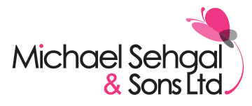
Michael Sehgal & Sons Ltd
28-40 Scotswood Road, Newcastle upon Tyne, NE4 7JB

- Shop at Michael Sehgal & Sons Ltd Schoolwear Superstore:

Our specialist uniform shop is open all year round; Monday – Saturday (10am-5.00pm) and is
conveniently situated, near the town centre, at 28-40 Scotswood Road, Newcastle NE4 7JB
(near the Life Centre).
Pop in as early as possible to avoid the rush and our friendly and experienced staff will be happy to
assist you. For back to school purchases please purchase by 31 July for guaranteed peace of mind,
as popular sizes do run out after this time.

- Order in store in July and you can pay by instalments:

You can visit us in July and select all of your required uniform items, then pay for them by
instalments over the summer holidays; with the comfort of knowing that we will keep everything for
you, ready to collect in time for the start of term.

- Purchase online via our website: (www.michaelsehgal.co.uk)

Parents can order on our new user-friendly website before 31 July and have uniforms delivered to
their home or workplace. This is additionally convenient for busy parents as the service is available
24 hours a day and 365 days a year, with swift automated processing and a variety of safe payment
and delivery options.

- Uniform Evening Dates 23rd and 24th of May (3pm-6pm)

Our team will be available to assist with ordering on these dates and will have a full range of
uniform stock for trying purposes. They will be happy to offer advice and to answer any queries.
We will accept payment on the night by cash or card for free delivery of all orders to school before
the end of term.

