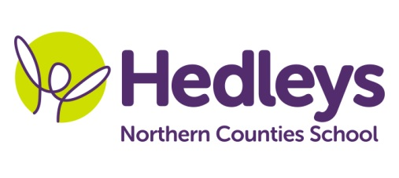
Spring Newsletter 2022
Raby Class
Dear Parents and Carers,
Welcome back, we hope you have all had a lovely Christmas holiday. It has been great to see everyone back in school and hear about what they got up to over the Christmas holidays and the lovely things they did.
This term the class topic will be about chocolate, exploring the history and covering topics such as Charlie and the chocolate factory to learning about chocolate relating to the Aztecs, this will include exploring music relating to the theme. We will explore character and scene themed arts and crafts, sensory food related chocolate activities and not forgetting our enrichment week just before half term.
This term, pupils will continue to do community based learning where appropriate and in line with current government guidelines, and this will include community visits where the pupils will have the opportunity to transfer their communication and numeracy skills into a functional community setting and practice their social skills. This term students will explore the metro which will include shopping trips and the local café to explore the wider community. The class will visit various walks throughout north Tyneside each Wednesday so could you please ensure that pupils come to school that day with appropriate clothing and footwear such as hat, coat and wellies heading into the colder weather and maybe some snow!

Pupils will access their swimming lessons on a Monday and Friday. Please ensure that you provide appropriate and named swimming attire and a towel for this lesson along with a wash bag containing shampoo and shower gel.

Mollie Henaghan our speech and language therapist will continue to deliver therapeutic input throughout the curriculum and we also have a newly appointed OT Lauren Curry who will be starting with us on the 7th of February.

In speech and language therapy sessions we will continue to develop each pupil’s communication skills, social skills and relationships through their preferred method of communication (verbal, sign, PECS, gesture) in a variety of motivating sessions throughout the week. These areas will be delivered in a range of group and individual settings and will be reviewed throughout the year to ensure we are providing appropriate and effective input. Intensive interaction will continue to be very much integrated throughout the school day and curriculum.
In occupational therapy sessions, this term the pupils will continue to develop their independence in different areas such as self-care, independent living, and community access. Those skills will be encouraged throughout the school day. Each pupil will also engage in relevant sensory programmes throughout the week to develop the ability to self-regulate and practice dexterity. Integrated work will continue to facilitate the achievement of individualised, child-centred goals.
Please don’t hesitate to contact us on
Best wishes,
Annmarie and the Raby class team.
Class teacher |  | SALT
Annmarie Conway  a.conway@percyhedley.org.uk |  | Mollie Henaghan m.henaghan@percyhedley.org.uk
Physio
NHS team on referral

