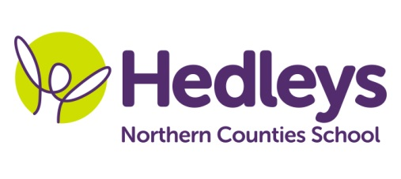
Spring Newsletter 2021-22
Norham Class
Dear Parents and Carers,
Happy new year! We hope you all had a lovely Christmas break, it’s lovely to have all of the students back and we are looking forward to the new term.
Within post 14 we will continue to focus on the four areas of the preparation for adulthood curriculum; the world of work, friends, relationships and community, good health and wellbeing and independent living skills.
Covid permitting, students will continue to engage in lots of community-based learning, including shopping, community sports and café visits where the pupils will have the opportunity to transfer their communication and numeracy skills into a functional community setting.
Throughout this term we will continue to work on ASDAN life skills challenge modules so our students can gain accreditation related to their learning. Following last terms success in enterprise and work experience, we will also continue to explore options in school and community and preferences related to this.
The aim for therapy continues to be around building relationships, social communication and functional skills building. Mollie our speech and language therapist and Zoe our occupational therapist will be spending their time providing therapeutic input within group and 1:1 sessions both in the classroom and the community.
Both speech and language therapy and occupational therapy will continue to be provided on a needs led basis for each student, which will be reviewed as appropriate throughout the year.
Students will continue to participate in weekly hiking on Mondays, swimming on Thursdays and community sports sessions on Tuesdays so if possible could you please provide appropriate equipment such as swim wear, a towel, hiking boots or similar and waterproofs. We can keep these items safe in school or send them home if that is preferred.
We would like to thank everyone for their continued support as we understand the difficulties associated with the pandemic. Please do not hesitate to get in contact if you have any questions or wish to discuss anything further.
Best wishes
Michelle, Gemma and the Norham Class team
Class teachers | OT | SALT
Michelle Waugh  m.waugh@percyhedley.org.uk  Gemma Thorby  g.thorby@percyhedley.org.uk | Zoe Pearson  zoe.pearson@percyhedley.org.uk | Mollie Henaghan  m.henaghan@percyhedley.org.uk
Physio - on referral
Roz Middleton - nuth.physio.ncs@nhs.net

