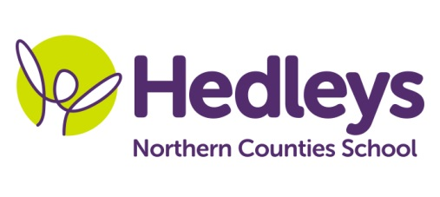
Spring Newsletter 2022
Lindisfarne Class
Dear Parents and Carers,
Happy New Year! We hope you have had a lovely Christmas period and it’s great to see all the students back at school after their break.
This term we shall continue to focus on our four areas of the Preparation for Adulthood curriculum; Friends, Relationships and Community, Good Health and Wellbeing, Independent Living Skills and World of Work.
Covid permitting, students will continue to engage in lots of community-based learning, including shopping, community sports and café visits where the pupils will have the opportunity to transfer their communication and numeracy skills into a functional community setting.
Throughout this term we will continue to work on ASDAN life skills challenge modules so our students can gain accreditation related to their learning. Following last terms success in enterprise and work experience, we will also continue to explore options in school and community and preferences related to this.
As previously stated, Students will continue to participate in weekly hiking, swimming and community sports sessions so if possible, could you please provide appropriate equipment such as swim wear, a towel, hiking boots or similar and waterproofs. We can keep these items safe in school or send them home if that is preferred.
We would like to thank everyone for their continued support as we understand the difficulties associated with the pandemic. Please do not hesitate to get in contact if you have any questions or wish to discuss anything further.

Best wishes,
Ashleigh and Lindisfarne class team

Class teacher | OT | SALT
Ashleigh Sinclair  a.sinclair@percyhedley.org.uk | Gemma Cooke  g.cooke@percyhedley.org.uk | Emily Searle  emily.searle@percyhedley.org.uk
Physio - on referral
Roz Middleton - nuth.physio.ncs@nhs.net

