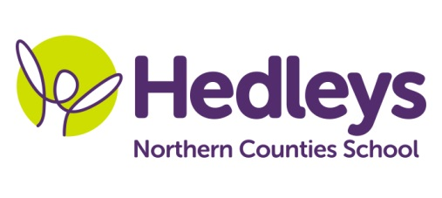
Spring Newsletter 2021-22
Ford Class

Dear Parents and Carers,
Happy New Year! We are so pleased to welcome the children back to school following the Christmas break. We hope you had a lovely festive period! The children had a fantastic first term and have all settled really well.

This term we are going to be using the text ‘The Very Hungry Caterpillar’ as a focus for our learning as several of the children have shown an interest in this topic. The children will access their activities through the Continuous Provision area and will learn through play and exploration. We will be developing our number recognition skills, having a ‘Number of the Week’ to focus on. Sensory activities will include numeracy-based tasks in order to develop their skills in an exploratory way.

As always, communication is a big focus in our class. Daily Attention Autism sessions will work on developing joint interaction with the children. They enjoyed their introductory sessions last term, and we are keen to build on the success of this.

We will be starting food exploration sessions with Erin and Zoe, building up tolerance for exploring different textures and food types. Another area we will be focusing on in PSE is personal hygiene, specifically toothbrushing. The children will have opportunities to use toothbrushes to ‘clean teeth’ in tuff trays which will allow them to become familiar with toothbrushing in a sensory environment.

The children will continue to develop their independence by making choices about which area of the Continuous Provision they would like to play in. Favourites last term were the construction area, outdoor area and messy play area. We will be accessing outdoors in all weathers, so if your child does not have wellies in school, would you please send some in.

Please do not hesitate to get in touch via email or phone if you have any questions or something which you would like to discuss.

Rebecca and the Ford class team

Class teacher | OT | SALT
Rebecca.lowe@percyhedley.org,uk | Zoe.pearson@percyhedley.org.uk | Erin.Kelly@percyhedley.org.uk

