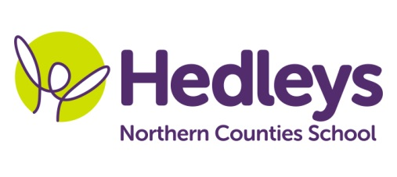
Spring Newsletter 2021-22
Alnwick Class
Dear Parents and Carers,
Happy new year! It was lovely to see all the pupils back after Christmas. We hope you have enjoyed the festive period and managed to spend time with loved ones.
We are really excited about our new topic “Chocolate” with the focus on the Roald Dahl story of “Charlie and the Chocolate Factory”. This topic will be embedded throughout the curriculum.
Covid permitting, this term, pupils will continue to engage in lots of community-based learning, including shopping and café visits where the pupils will have the opportunity to transfer their communication and numeracy skills into a functional community setting.

Pupils will have their swimming lessons on a Monday. Please ensure that you provide appropriate and named swimming attire and a towel for this lesson. We can keep these at school and wash them each week or we can send them home if you would prefer.

Both speech and language therapy and occupational therapy will continue to be provided on a needs led basis for each pupil, which will be reviewed as appropriate throughout the year.
We will continue to develop each pupil’s communication skills, social skills and relationships through their preferred method of communication (verbal, sign, PECS, VOCA and gesture) in a variety of structured and non-structured activities throughout the week.
Each pupil will also engage in any relevant sensory programmes to develop self-regulation using activities that each pupil is motivated by.
Please don’t hesitate to contact us on

Class teacher | OT | SALT
Jen Dunn jennifer.dunn@percyhedley.org.uk | Emma Coomber  Emma.coomber@percyhedley.org.uk | Emily Davis  emily.davis@percyhedley.org.uk
Physio - on referral
Roz Middleton - nuth.physio.ncs@nhs.net

Best wishes
Jen and the Alnwick class team

