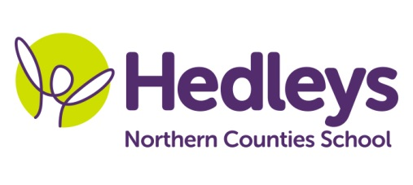
Spring Newsletter 2021-22
Penshaw Class

Dear Parents and Carers,

We hope everyone managed to have a safe but enjoyable Christmas break and have been able to keep up-to-date with the changing rules regarding covid19. In school, we will ensure that we continue to follow the guidelines and modify our daily routines as necessary. The teaching and therapy team will make sure home learning packs are available when needed and add to them as necessary should students be learning from home for periods throughout the term.

We will be continuing working towards accreditations in English and Maths and will be following various Asdan programmes, completing challenges and modules focussing on humanities and life skills. In other areas the curriculum, such as computing, DT and art, we will continue to add to their Personal Independence Programme and Entry Level portfolios. In our work-related learning lessons, we will research various jobs and work skills and will be building opportunities for students to develop organisational and practical skills. Students will be working both individually and as members of a team. We will review work-related learning opportunities within the school environment as well as selected work experience placements.

We will continue to build time to undertake a range of well-being activities into the school day, and staff will be organising activities and various lunchtime clubs that the students can choose to attend.

If you have any enquiries or concerns, please do not hesitate to contact us.
Best wishes
Jamie, Julie and the Penshaw class team

Class teachers | OT | SALT
Jamie & Julie jamie.mathews@percyhedley.org.uk  j.clark@percyhedley.org.uk | Julie Osborne  j.osborne@percyhedley.org.uk | Emily Davis  e.davis@percyhedley.org.uk

