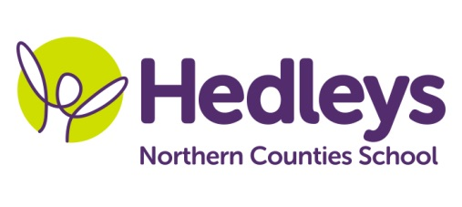
Spring Newsletter 2021-22
Angel Class

Dear Parents and Carers,

Welcome back
Hope everyone has had an amazing Christmas and New Year and managed to spend some much needed time with family and friends.

This term Angel class topic is houses and homes. We will be covering the following:
English – Hansel and Gretel and The Three Little Pigs
Maths – addition and subtraction and shapes
Science – Materials and their properties
Humanities – different types of houses
RSE – family and people who we live with
RE – God’s house

We have two new members of staff working in Angel class. They are Amanda and Emma and they have already started to get to know the students.

As usual if you need anything please contact me at school on 0191 2815821 or you can email us on:

Class teachers | OT | SALT
Helen Blakelock h.blakelock@percyhedley.org.uk | Julie Osborne  j.osborne@percyhedley.org.uk | Catrin Jones  catrin.jones@percyhedley.org.uk

