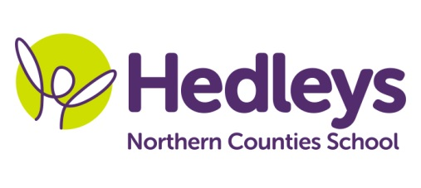
Summer Newsletter 2021
Raby Class
Dear Parents and Carers,
Welcome back we hope you have all had a lovely Easter. It has been great to see everyone back in school and hear about what they have been up to over the holidays now we have had more places to visit!
This term the class topic will be Coast and Boats, which will include exploring music relating to pirates, under the sea and Disney themed characters. We will explore beach themed arts and crafts and not forgetting our enrichment week just before half term where boat building will commence!
This term, pupils will continue to do community based learning where appropriate and in line with current government guidelines, this will include community visits where the pupils will have the opportunity to transfer their communication and numeracy skills into a functional community setting and practice their social skills. The class will visit various walks throughout north Tyneside and Northumberland each Wednesday so could you please ensure that pupils come to school that day with appropriate clothing, footwear and sun tan lotion for the activity and the weather and if you wish to supply your child with a packed lunch this is fine or school can provide this.

Pupils will continue their swimming lessons on a Monday and Thursday. Please ensure that you provide appropriate and named swimming attire and a towel for this lesson along with a wash bag containing shampoo and shower gel.

Mollie Henaghan our speech and language therapist and Joanna Taylor our occupational Therapists will continue to deliver therapeutic input throughout the curriculum.

In speech and language therapy sessions we will continue to develop each pupil’s communication skills, social skills and relationships through their preferred method of communication (verbal, sign, PECS, gesture) in a variety of motivating sessions throughout the week. These areas will be delivered in a range of group and individual settings and will be reviewed throughout the year to ensure we are providing appropriate and effective input. This term, SaLT and teacher joint led sessions will include: ‘Play Skills’, ‘Sensory Story’, and ‘Communication’. This term there will also be continued increased focus on ‘Intensive Interaction’ sessions and strategies being used across the school day to support our students to build and maintain good relationships with their staff and peers.
In occupational therapy sessions, this term the pupils will continue to develop their independence in different areas such as self-care, independent living, and community access. Those skills will be encouraged throughout the school day. During the weekly Tuesday group session, students will have opportunities to access a number of activities relevant to their individual sensory needs supporting the ability of emotional regulation necessary for learning. Each pupil will also engage in relevant sensory programmes throughout the week to develop the ability to self-regulate and practice dexterity. Integrated work will continue to facilitate the achievement of individualised, child-centred goals.
Please don’t hesitate to contact us on

Class teacher | OT | SALT
Annmarie Conway  a.conway@percyhedley.org.uk | Joanna Taylor  joanna.taylor@percyhedley.org.uk | Mollie Henaghan m.henaghan@percyhedley.org.uk

Best wishes,
Annmarie and the Raby class team

