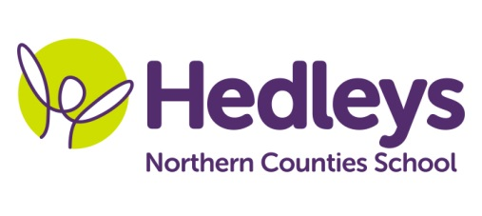
Summer Newsletter 2020-21
Ford Class
Dear Parents and carers
I hope you had a lovely time during the Easter holidays.
Our topic this term is under the sea. We will be doing a range of activities associated with mermaids and the sea during Art sessions, listening to the ‘Little mermaid’ story, exploring all the sensory props, sensory booklets and making crafts related to dinosaurs using a variety of resources and equipment.
For Science we will be developing our understanding of how the shapes of solid items can be changed by squashing, bending, twisting and stretching and explore the composition of earth as well as the rock cycle using a variety of resources including a sink and float experiment and an oil and water experiment
For RE we will be focusing on the importance of water and each week we will be watching a PowerPoint presentation about the importance of water, exploring the sensory booklets and making a crafts related to the importance of water.
For humanities we will be focusing on different seasons. Every week we will be listening/watching a power point presentation about a specific season (autumn and winter) as well as explore the sensory books linked to the specific season, do the matching activities, explore the sensory booklets and create a craft related to a specific season using a variety of resources and equipment. (autumn – autumn tree and finger print craft, leaf people, pumpkin handprint / pumpkin wreath, paper plate scarecrow, winter – snowman in a bag, snowflake handprint, icy cold snow paint, winter bird feeders)
For careers each week we will be learning about different professions and exploring a variety of props, as well as completing matching activities of people doing different professions, places of work matching activities, tools/ equipment and vehicles matching activities, looking at display cards about different professions. Children will also be allocated small jobs around the classroom (laminating, cutting, shredding, recycling)
Numeracy will be based on a variety of topics like numbers, measure, shapes and time and we will be doing lots of fun and interesting activities.
Every Wednesday afternoon we will be going shopping to get snacks at a local shop.
During food tech students will be learning how to follow a method for a recipe, using fine motor skills when chopping ingredients and discussing what ingredients they need to add to make a dish. This term’s recipes will include pizza in a mug.
Within our communication in the community sessions, our students we will be accessing shops in the local area and a cafe to promote independence, which focuses on developing appropriate social skills within daily living tasks
Our Speech and Language Therapist will be taking advantage of the warmer summer months by taking our sessions outside, working on the children’s social communication and requesting skills in activities such as water play which the children are very motivated by! Every week the children will participate in a play skills session which will incorporate both Speech and Language Therapy and Occupational Therapy goals; aiming to develop peer interaction, turn taking skills and praxis.
The occupational therapist will be working on the further development of student's independence skills and these will be encouraged throughout the school day. Weekly Monday group will focus on food exploration and development of fine motor skills while making healthy, fun frozen snacks using yoghurt and fruits. During sensory integration sessions, students will have opportunities to access a number of activities relevant to their individual sensory needs supporting the ability of emotional regulation necessary for learning. Integrated work will continue to facilitate the achievement of individualised, child-centred goals.
Pamela will continue to teach music to the class .
If you have any further questions you would like to discuss please don't hesitate to contact us.
Thank you
Ilianna, Joanna, Erin and the Ford class team

Class Teacher | OT | SALT
Ilianna Katsavria  i.katsavria@percyhedley.org.uk | Joanna Taylor  Joanna.taylor@percyhedley.org.uk | Erin Kelly  erin.kelly@percyhedley.org.uk
Physio – on referral
Roz - nuth.physio.ncs@nhs.net

