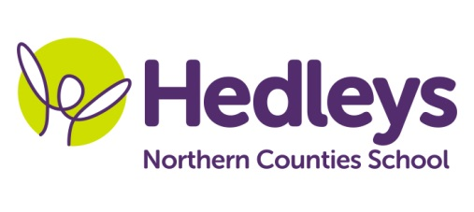
Summer Newsletter 2020-21
Warkworth Class
Dear Parents and Carers,
We hope you all had a lovely break and it’s great to see all of our students ready for the new term. Our class team remains mainly the same, however we have gained 2 new members of staff called Brian and Iwona, alongside our therapists Victoria Box our SaLT and Shauna Garrity our OT. We have also gained a new addition to the team called Nemo (our pet fish), the students are doing a lovely job with ensuring he is fed and his tank is clean.
We are very excited about this terms topic ‘coasts and boats’. Within communication, through narrative therapy and sensory story students will develop their understanding of ‘wh’ words, answering simple questions about stories and characters as well as sequencing events, whilst exploring props. We will use the colourful semantics and shape coding approaches to develop writing skills in extending word choices and structuring language to form sentences. In numeracy our focus for this term is around shapes and coin recognition, which we will further develop through real life situations such as accessing the café and shopping. Science will focus on water, ‘sinking and floating’ ‘motion and forces’ and ‘suitability of materials.’ Students will follow instructions to set up and carry out investigations. We will heavily focus on recording our experiments using scientific language, beginning to predict what might happen as well as drawing diagrams and labelling.
In other sessions activities will link with our topic theme with a focus on reading and following instructions, making choices and communicating ideas. In food technology students will make a range of dishes such as humus and Indian snacks and drinks. We will explore different materials in art and use to create our own pieces of work to do with coasts and boats for our lovely displays. Within forest school we will develop shared working, contributing to tasks through responding to ideas, making choices and sharing resources and spaces engaging in activities including making rafts from natural materials. We will continue with weekly visits to the supermarket and local shops to enable students to generalise skills across settings and apply within functional contexts. This will focus on carrying out the steps of the routine with increasing independence, coin recognition and responding to mathematical vocabulary and individual work with students engaging in smILE therapy. As part of our community access we will be continuing with the café in Jesmond as well as accessing the metro, to explore coastal walks and learning the life skill of public transport.
In therapy sessions students will engage with weekly narrative therapy beginning with stories around ‘Vikings’ where pupil’s will develop their understanding of characters, events and emotions within the story and their ability to comment upon these, as well as focusing heavily on sentence structures. Our social skills session enables students to practice interacting appropriately with each other, making requests for story items, sharing and taking turns with peers. We will continue to focus on social communication and interaction skills through directed play, encouraging conversations and developing their ability to share activities and interact with each other. Our occupational therapist will also continue to lead a weekly fine motor skills session to develop fine motor skills with students taking part in a range of motivating tasks such as threading, making stretchy slime to practice letter formation to target individual needs and support handwriting skills. As always 1:1 occupational and speech and language therapy sessions will focus on each student’s individual targets and support to engage in any relevant sensory programmes to enable self-regulation.
We have recently started a new session with Sam called media studies which the students are all showing an interest in and engaging in, we have learned about different focus photographs and beginning to take our own photographs. We are excited to see what else we will be learning about.
Please don’t hesitate to contact us on
Class Teacher | OT | SALT
Megan Lockey  m.lockey@percyhedley.org.uk | Shauna Garrity  s.garrity@percyhedley.org.uk | Victoria Box  victoria.box@percyhedley.org.uk
Best wishes
Megan, The Warkworth class team and Nemo.

