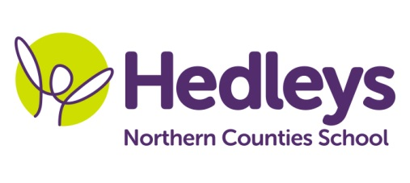
Summer Newsletter 2020-21
Aydon Class

Dear Parents and Carers,
We hope you enjoyed the Easter Break! We are looking forward to starting our exciting Summer topic of ‘Coasts and Boats’. This theme will act as a stimulus for our learning throughout the Summer term.
Maths sessions will work on developing skills such as addition and subtraction, composition of numbers, number bonds and subitising, based upon this term’s theme. In communication/English, the pupils will complete individualised, tailored activities linked to our Summer topic. We will be using a range of stimuli during these sessions, including film, books and poetry.
Science sessions this term will be focussed on ‘growing’, where we will be conducting experiments based on the conditions that plants need to survive. We will find out the optimum conditions which plants need to survive and thrive, and we will grow our own beautiful sunflowers. We will also be relating this term’s topic to cover aspects of ‘materials and properties’, such as boat design.
During geography we will be learning about the explorer Christopher Columbus and his travels across the oceans. We will also learn about the United Kingdom and its capital cities. In history we will be covering Vikings and we will be completing craft and communication activities based upon how they lived.
Our PSHE (RSE) sessions this term will be focusing on healthy living and what we need to do to look after ourselves. Wellbeing sessions will promote mindfulness, relaxation and calm through guided mediation, breathing exercises and activities linked to books such as ‘My Magic Breath’ and ‘Fill up a Bucket’.
The children will also access weekly baking therapy and sensory massage sessions with our class therapists, Erin and Gemma.
Please don’t hesitate to contact us on rebecca.lowe@percyhedley.org.uk (Rebecca) or r.woodford@percyhedley.org.uk (Ruth) if you have questions.
Best wishes,
Ruth, Rebecca and the Aydon class team.
Class Teacher | OT | SALT
Ruth Woodford & Rebecca Lowe  r.woodford@percyhedley.org.uk  Rebecca.lowe@percyhedley.org.uk | Gemma Cooke  g.cooke@percyhedley.org.uk | Erin Kelly  Erin.kelly@percyhedley.org.uk

