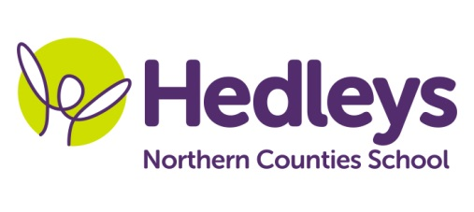
Summer Newsletter 2020-21
Alnwick Class
Dear Parents and Carers,
Welcome to the Summer term! We hope you enjoyed the Easter break, making the most of both the sunshine and the snow! This term sees the return of the ‘Coasts & Boats’ topic so we will be exploring all the fun of the sand and seas.
This term our team is Rachel, Rebecca, Helen, Sue, Kim, Kelly, Lidia, Nikki, Gemma, Cathy and Angela. Speech and Language Therapy will be provided by Emily Davis and Occupational Therapy will be provided by Tara Tordoff.
Our stories this term will include Tiddler, The Snail and the Whale, Rainbow Fish and Busy Boats. We will also be using the Moody Monsters story as a stimulus in our Wellbeing sessions this term.
We will focus on the following areas of learning:
- We will continue with visits into the community to transfer the communication and numeracy work we are doing in school.
- Science sessions this term will be focussed on floating, sinking, buoyancy, boat building and motion in water.
- Food technology sessions for the first half term will be focused on toasting different foods.
Speech and language therapy input will focus on further developing communication skills and vocabulary within a ‘total communication’ approach, including use of PECS, VOCA and spoken language as appropriate. Individual programmes will be followed throughout the school week, including sessions such as sensory story and play skills, as well as topic-based sentence building using colourful semantics and shape coding strategies.
Occupational therapy will be working on functional independence skills as well as fine and gross motor tasks, incorporating sensory integration into the student’s day. One to one sessions will work on individual targets and group sessions such as baking therapy, fine motor and play skills will incorporate the students SCERTS targets which look to develop the students emotional regulation and social communication with their staff and peers.
Please don’t hesitate to contact us on
Class Teacher | OT | SALT
Rebecca Gillet & Rachel English  r.gillet@percyhedley.org.uk r.english@percyhedley.org.uk | Tara Tordoff  tara.tordoff@percyhedley.org.uk | Emily Davis  Emily.davis@percyhedley.org.uk

Best wishes,
Rachel, Rebecca and the Alnwick class team.

