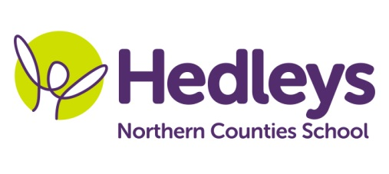**Summer Newsletter 2020-21**

**Dunstanburgh Class**

Dear Parents and carers

Welcome back we hope you have had an amazing Easter holiday!

We have lots of fabulous sessions planned for this half term. This term we are focusing on boats and coasts.

Science sessions will have a pirate theme and there will be lots of sensory based activities for your child to engage in.

We have summer art activities set to get us in the mood for the sun shining and gardening sessions where we shall be planting our own vegetables.

In math’s we will be focusing on preparing for adulthood where the students will choose their own snack walk to the shops and pay for the snack and then look at coin recognition of the coins they have received in change.

We have introduced a new signing singing session to our timetable so students can engage with their peers and choose their own instruments to join in with the session.

Pupils have been enjoying a sensory massage with our class OT Gemma which has had a really positive impact in social interaction for our students with their peers and with their staff. Gemma will continue to deliver shopping and food technology sessions in preparation for adulthood.

Our class SaLT Emily will continue to deliver sensory story sessions which will focus on myths and legends this half term. The story we shall look at and share is Room on the Broom.

We look forward to the term ahead and sharing all our fabulous sessions with you via Earwig.

Thanks so much

Jess and the Dunstanburgh class team

|  |  |  |
| --- | --- | --- |
| **Class Teacher** | **OT** | **SALT** |
| Jess Prince  [j.prince@percyhedley.org.uk](mailto:j.prince@percyhedley.org.uk) | Gemma Cooke  [g.cooke@percyhedley.org.uk](mailto:g.cooke@percyhedley.org.uk) | Emily Davis  [e.davis@percyhedley.org.uk](mailto:e.davis@percyhedley.org.uk) |