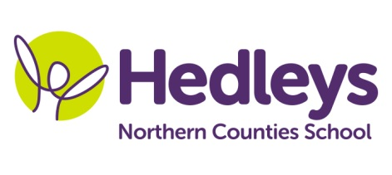
Registration Information

Please complete and return to school for the attention of Lauren Stephenson, Lead Administrator

PERSONAL INFORMATION
Student’s Legal First Name
Student’s Middle Name
Student’s Legal Surname
Student’s Preferred Surname (If different from above)
Student’s Preferred First Name (If different from above)

Date of Birth: / / Gender: Male Female

Primary Disability: HI / PMLD / ASD

Other Disabilities:

STUDENT’S ADDRESS
Address Line 1
Address Line 2
Town/City
County
Post Code

MOTHER’S INFORMATION
Name
Address
(if different from student)

Relationship to Student
Home Telephone Number
Mobile Telephone Number
Work Telephone Number
Email Address

How would you like your letters addressed: Mr & Mrs / Mr / Mrs / Ms / Miss / Dr / other

FATHER’S INFORMATION
Name
Address
(if different from student)

Relationship to Student
Home Telephone Number
Mobile Telephone Number
Work Telephone Number
Email Address

How would you like your letters addressed: Mr & Mrs / Mr / Mrs / Ms / Miss / Dr / other

CARER’S INFORMATION
(person with Parental Responsibility if not mother or father)
Name
Address
(if different from student)

Relationship to Student
Home Telephone Number
Mobile Telephone Number
Work Telephone Number
Email Address

How would you like your letters addressed: Mr & Mrs / Mr / Mrs / Ms / Miss / Dr / other

EMERGENCY CONTACTS
Name | Relationship to Student |  | Telephone Number
1
2
3
4

LOCAL AUTHORITY INFORMATION
Local Authority
SEN Caseworker’s Name
Telephone Number

SOCIAL WORKER
Name
Telephone Number

GP
Name
Address

Telephone Number

PROFESSIONALS INVOLVED WITH STUDENT
Name | Role/Job Title |  | Telephone Number
1
2
3
4

ETHNIC ORIGINS OF STUDENT
(Optional information used for equality monitoring)
Any other Asian background | Bangladeshi | Indian | White and Black African
Any other Black background | Black African | Pakistani | White and Black Caribbean
Any other Ethnic Group | Black Caribbean | Prefer not to say | White British
Any other Mixed background | Chinese | Traveller of Irish heritage | White Irish
Any other White background | Gypsy/Roma | White and Asian

First language of student:

Language spoken at home:

Country of birth: Nationality:

If student has moved from another country, date of arrival into the UK:

National Identity (please tick)

British English Irish Welsh Other Prefer not to say

Please answer the following questions:
 | Yes | No
Is your child entitled to free school meals?
Are either parents members of the Armed Forces?
Was your child adopted from care or left care under a guardianship or care arrangements order?

