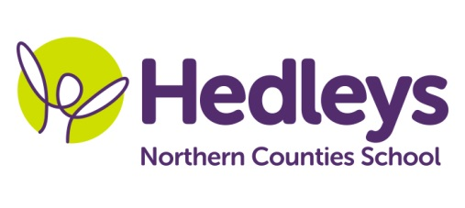
Autumn Newsletter 2020-21
Raby Class
Dear Parents and Carers,
Welcome back to school! It was lovely to see all the pupils back after the summer holidays and have everyone back in class again.
All the pupils are settling in nicely and are getting used to life back in the classroom with all their peers. We are really excited about our new topic; “Dinosaurs” with our focus being on fossils and our earth and this topic will be embedded throughout the curriculum.
This term, pupils will continue to do lots of community based learning where appropriate and in line with current government guidelines and this will include café visits where the pupils will have the opportunity to transfer their communication and numeracy skills into a functional community setting which will hopefully begin to take place after October half term. The class will visit various walks throughout north Tyneside and Northumberland each Wednesday so could you please ensure that pupils come to school that day with appropriate clothing and footwear for the activity and the weather and if you wish to supply your child with a packed lunch this is fine or school can provide this.

Pupils will continue their swimming lessons on a Monday and Thursday. Please ensure that you provide appropriate and named swimming attire and a towel for this lesson. We can keep these at school and wash them each week or we can send them home if you would prefer.

In terms of staffing; I would like to introduce myself, my name is Annmarie Conway and I have taken over from Jen this year as the new class teacher. John Harter has taken over the role of class HLSSA and will be delivering Art and PE. Mollie Henaghan is our new speech and language therapist and Doug McQuillin and Joanna Taylor are our new class occupational Therapists and will deliver therapeutic input throughout the curriculum.

In speech and language therapy sessions we will continue to develop each pupil’s communication skills, social skills and relationships through their preferred method of communication (verbal, sign, PECS, gesture) in a variety of motivating sessions throughout the week. These areas will be delivered in a range of group and individual settings and will be reviewed throughout the year to ensure we are providing appropriate and effective input. This term, SaLT and teacher joint led sessions will include: ‘Play Skills’, ‘Sensory Story’, ‘Magic Carpet’ and ‘Communication’. This term there will also be an increased focus on ‘Intensive Interaction’ sessions and strategies being used across the school day to support our students to build and maintain good relationships with their staff and peers.
In occupational therapy sessions this term the pupils will continue to develop their independence in different areas such as self-care, life-skills and community access. Individual occupational therapy sessions will focus on each pupil’s level of independence and building on this. This term occupational therapy sessions will also incorporate play to help develop the social and peer interaction skills of each student. Each pupil will also engage in any relevant sensory programmes to develop the ability to self-regulate using motivational activities. These targets will be worked on using both group and individual sessions as part of their daily timetable enabling opportunity to review and change sessions to ensure the pupils are being provided with opportunity to meet their full potential.
Please don’t hesitate to contact us on the below emails if needed

Best wishes,
Annmarie and the Raby class team.

Class teacher | OT | SALT
Annmarie Conway  a.conway@percyhedley.org.uk | Doug Mquillin  Joanna Taylor  d.mcquillin@percyhedley.org.uk  joanna.taylor@percyhedley.org.uk | Mollie Henaghan m.henaghan@percyhedley.org.uk
Physio - on referral
Roz Middleton
nuth.physio.ncs@nhs.net

