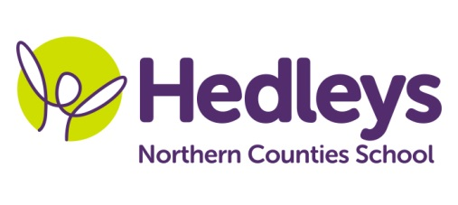
Autumn Newsletter 2020-21
Ford Class
Dear Parents and Carers,
I hope you had a lovely time during the summer holidays.
Our topic this term is Dinosaurs. We will be doing a range of activities associated with Dinosaurs during Forest School and Art, listening to the ‘Dinosaurs’ story , exploring all the sensory props and making crafts related to dinosaurs using a variety of resources and equipment (e.g. paper plate dinosaurs, cupcake dinosaurs, hand/foot print dinosaurs, dinosaur pasta skeletons, balloon dinosaurs, dinosaur fossils, edible dinosaur bones).
For forest school we will be making crafts related to dinosaurs as well using nature resources such as leaves, twigs and flowers (e.g. dinosaur nature nests, rock dinosaur, mud dinosaurs, leaf dinosaurs, salt dough nature dinosaurs, decorate dinosaurs using mud paint, edible dinosaurs made out of vegetables and fruit).
For Science we will be developing our understanding that most living things, live in habitats in which they are suited, while identifying and naming a variety of animals as well as their habitats. Each week we will be listening/watching a power point presentation, exploring props as well as the sensory books linked to different animal habitats (e.g. arctic foam playdough, dessert in a box/bottle, ocean in a bottle/plastic bag, bird/nest box, savannah sensory experience, rainforest habitats)
For RE we will be focusing on the Sikhism religion and each week we will be making a craft related to this (e.g. turban, kalgri craft, making kanga comps, mala making- breaded bracelet, making and decorating gurdwara flags, the four doors craft, chaur sahib)
Numeracy will be based on a variety of topics like numbers, measure, shapes and time and we will be doing lots of fun and interesting activities.
Every Wednesday afternoon we will be going shopping to get snacks at the local Tesco shop.
During food tech students will be learning how to follow a method for a recipe, fine motor skills when chopping ingredients and discussing what ingredients they need to add to make a dish. This term’s recipes are dinosaur egg rice crispies and dinosaur footprint fruit skewers.
Within our communication in the community sessions, our students we will be accessing shops in the local area and the cafe to promote independence, which focuses on developing appropriate social skills within daily living tasks.
As a class we will be continuing to focus on communication and pupils will have the opportunity to practice communication skills and use their preferred method of communication, within break and lunchtime periods and within communication sessions.
Our occupational therapist will be working on the further development of student's self-care and independence skills which will be promoted throughout the school day. During weekly sensory integration sessions, students will have opportunities to explore a number of activities relevant to their individual sensory needs supporting the ability of emotional regulation necessary for learning. Most preferred activities will be incorporated into each child's sensory passport and daily routine. Students will also have regular opportunities to interact with the magic carpet, which is a fantastic resource promoting communication and development of meaningful occupations including playing, learning, and socializing. The occupational therapist will also deliver a weekly session focusing on fine motor skills, which will include elements of food exploration. Integrated work will continue to facilitate the achievement of individualised, child-centred goals in line with each student's Educational Health Care Plan.
Pamela will continue to teach music.
If you have any further questions you would like to discuss please don't hesitate to contact us.
Thank you
Ilianna and the Ford Class team

Class Teacher | OT | SALT
Ilianna Katsavria  i.katsavria@percyhedley.org.uk | Joanna (Asia) Taylor  joanna.taylor@percyhedley.org.uk | Erin Kelly  erin.kelly@percyhedley.org.uk
Physio - on referral
Roz Middleton
nuth.physio.ncs@nhs.net

