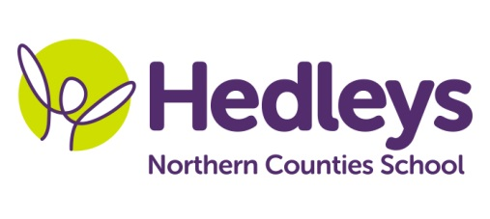
Autumn Newsletter 2020-21
Warkworth Class
Dear Parents and Carers,
We are pleased to welcome everybody back after such an uncertain time and the summer holidays. We hope you all had a lovely break and it’s great to see all of our students ready for the new term. Our class team remains mainly the same, however we have gained a new member of staff called Holly, alongside our therapists; Ashleigh Richardson our Speech and Language Therapist and Shauna Garrity our Occupational Therapist.
We are very excited about this terms topic ‘Dinosaurs’. Within communication, through narrative therapy and sensory story students will develop their understanding of ‘wh’ words, answering simple questions about stories and characters as well as sequencing events, whilst exploring props. We will use the colourful semantics and shape coding approaches to develop writing skills in extending word choices and structuring language to form sentences. In numeracy our focus for this term is around data, collecting and recording data from peers and staff using stopwatches, weighing items with scales and identifying big and small items. Science will focus on rocks where students will take part in practical experiments and investigations making igneous, sedimentary and metamorphic rocks exploring how to make them and how they look different. Students will follow instructions to set up and carry out investigations and record using pictures, symbols and words.
In other sessions activities will link with our topic theme with a focus on reading and following instructions, making choices and communicating ideas. In food technology students will make sandwiches independently to develop this basic life skill of a simple recipe. We will explore different materials in art and use to create our own pieces of work to do with dinosaurs for our lovely displays. Within forest school we will develop shared working, contributing to tasks through responding to ideas, making choices and sharing resources and spaces engaging in activities including making hideouts. We will continue with weekly visits to the supermarket and local shops to enable students to generalise skills across settings and apply within functional contexts. This will focus on carrying out the steps of the routine with increasing independence, coin recognition and responding to mathematical vocabulary and individual work with students engaging in smILE therapy. As part of our community access we will be introducing the café, starting with our own school café and hopefully work towards accessing one in the community.
In therapy sessions students will engage with weekly narrative therapy beginning with the story of ‘Harry and the bucketful of dinosaurs’ where pupil’s will develop their understanding of characters, events and emotions within the story and their ability to comment upon these. Our social skills enables students to practice interacting appropriately with each other, making requests for story items, sharing and taking turns with peers. We will continue to focus on social communication and interaction skills through directed play, developing their ability to share activities and interact using a range of activities including jewellery therapy and turn taking games this term. Our occupational therapist will also continue to lead a weekly fine motor skills session to develop fine motor skills with students taking part in a range of motivating tasks such as threading, making stretchy slime to practice letter formation to target individual needs and support handwriting skills. As always 1:1 occupational and speech and language therapy sessions will focus on each student’s individual targets and support to engage in any relevant sensory programmes to enable self-regulation.
Best wishes Megan and the Warkworth class team
Class Teacher | OT | SALT
Megan Lockey  m.lockey@percyhedley.org.uk | Shauna Garrity  s.garrity@percyhedley.org.uk | Ashleigh Richardson  a.richardson@percyhedley.org.uk
Physio – on referral
Roz Middleton - nuth.physio.ncs@nhs.net

