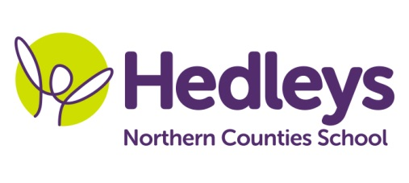
Autumn Newsletter 2020-21
Aydon Class
Dear Parents and Carers,
Welcome back! We hope you managed to enjoy the summer break in spite of the strange times we are living in. We are really looking forward to welcoming the children back, and settling them into school life. We have an exciting topic to begin the new academic year with, and can’t wait to get started.
This year our team is Ruth, Carole, Laura, Natalie, Ellen, Alison, Donna, Kirsty and Fiona. Speech and Language Therapy will be provided by Erin Kelly and Occupational Therapy will continue to be provided by Gemma Cooke. We are also joined by a new teacher, Rebecca Lowe.
This term the class topic will be ‘Dinosaurs’. Communication will focus on the ‘Dinosaur that pooped a planet’ story, and other dinosaur related stories. Other sessions such as art, numeracy and science will act as stimulus from this topic.
We will focus on the following areas of learning:
- We will continue with visits into the community to transfer the communication and numeracy work we are doing in school.
- Science sessions this term will be focussed on volcanoes rocks, fossils, herbivores and carnivores, and plants and animals.
- During Food Technology sessions we will be creating dinosaur inspired dishes.

We are also starting a PSHE/Well-Being session which will focus on feelings and emotions.
Our new speech and language therapist, Erin, will be starting with us very soon and we look forward to her joining the team.

Please don’t hesitate to contact us if needed

Best wishes,

Ruth, Rebecca and the Aydon Class team.

Class Teachers | OT | SALT
Ruth Woodford  r.woodford@percyhedley.org.uk  Rebecca Lowe  rebecca.lowe@percyhedley.org.uk | Gemma Cooke  g.cooke@percyhedley.org.uk | Erin Kelly  erin.kelly@percyhedley.org.uk
Physio - on referral
NHS Team
nuth.physio.ncs@nhs.net

