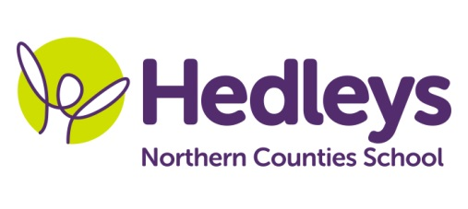**Autumn Newsletter 2020-21**

**Alnwick Class**

Dear Parents and Carers,

Welcome back! We hope you managed to enjoy the summer break in spite of the strange times we are living in. We are really looking forward to welcoming the children back to school, particularly those who have been home learning since March. We have an exciting topic to begin the new academic year with and can’t wait to get started.

This year our team is Rachel, Rebecca, Helen, Sue, Kim, Kelly, Kadiza and Angela. Speech and Language Therapy will be provided by Emily Searle and Occupational Therapy will be provided by Anna Sallows.

This term the class topic will be ‘Dinosaurs’. Communication will focus on the ‘Dinosaur that pooped a planet’ story and our wellbeing sessions will take inspiration from the story ‘Worrysaurus’.

We will focus on the following areas of learning:

* We will continue with visits into the community to transfer the communication and numeracy work we are doing in school.
* Science sessions this term will be focussed on rocks, fossils, earthquakes and volcanoes.
* During Food Technology sessions we will be developing our cutting skills to make some fun dinosaur shaped creations and making sure we clean up appropriately.

Speech and language therapy input will focus on further developing communication skills and vocabulary within a ‘total communication’ approach, including use of PECS, VOCA and spoken language as appropriate. Individual programmes will be followed throughout the school week, including sessions such as sensory story and play skills, as well as topic-based sentence building using colourful semantics and shape coding strategies.

Occupational therapy will be working on functional independence skills as well as fine and gross motor tasks, incorporating sensory integration into the student’s day. One to one sessions will work on individual targets and group sessions such as baking therapy, fine motor and play skills will incorporate the students SCERTS targets which look to develop the students emotional regulation and social communication with their staff and peers.

Please don’t hesitate to contact us on the below email addresses if needed.

Best wishes,

Rachel, Rebecca and the Alnwick class team.

|  |  |  |  |
| --- | --- | --- | --- |
| **Class Teachers** | **OT** | **SALT** | |
| Rebecca Gillet  [r.gillet@percyhedley.org.uk](mailto:r.gillet@percyhedley.org.uk)  Rachel English  [r.english@percyhedley.org.uk](mailto:r.english@percyhedley.org.uk) | Anna Sallows  [a.sallows@percyhedley.org.uk](mailto:a.sallows@percyhedley.org.uk) | Emily Searle  [emily.searle@percyhedley.org.uk](mailto:emily.searle@percyhedley.org.uk) | |
| **Physiotherapy – On referral** | | |
| Roz Middleton  [nuth.physio.ncs@nhs.net](mailto:nuth.physio.ncs@nhs.net) | | |