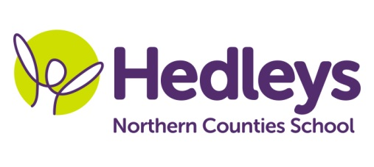
Autumn Newsletter 2020-21
Dunstanburgh Class
Dear Parents and Carers,
Welcome back! I hope you are all well; we are so excited to see all of our students in class again. It has been lovely spending time with them and seeing how well they have all settled back into their environment and routines but we will continue to focus on supporting students to cope with the changes they have faced.
Our class team for this year is Michelle Waugh as class teacher alongside Gemma Blackman as our HLSSA who will work together collaboratively to ensure consistency for students throughout the week. Our therapists remain as Emily Searle our Speech and Language Therapist and Gemma Cooke our Occupational Therapist.
Our life skills curriculum will continue to develop student’s independence and pursue their interests to prepare them for adult life. Students will have the opportunity to take part in weekly work related learning including DT, minibus cleaning enterprise, administration roles and running our own café. As soon as is possible we will continue with our community access, accessing facilities for community sports activities and developing functional communication and numeracy skills through café and supermarket visits. To promote a healthy lifestyle and support student’s physical and mental wellbeing our RSE topic is around understanding and making healthy choices and wellbeing sessions taking part in yoga and guided relaxation as well as identifying and engaging in activities which help us feel calm. Focused English and Maths session will build on individual skills and students will then have the opportunity to apply these within practical contexts across the curriculum.
Some of our students will be engaging in a full day hike and others a local half day walk as part of the Duke of Edinburgh award and student’s will be engaging in PE and swimming sessions on a weekly basis so appropriate footwear, a change of clothes and swimming kit will be needed if we do not already have them in school.
In therapy sessions this term we will continue to develop each pupil’s communication skills, social skills and emotional regulation in a variety of motivating group sessions and individual 1:1 sessions throughout the week. This will include group baking and Lego therapy, developing student’s ability to maintain interactions, practice joint attention, share activities and take turns appropriately. Our occupational therapist will also lead a weekly life skills session to develop daily living skills where students shop for ingredients and follow a visual recipe with increasing independence. 1:1 occupational and speech and language therapy will focus on each pupil’s individual targets and use a range of relevant approaches including smILE therapy, PECS and shape coding. Students will also engage in any relevant sensory programmes to enable self-regulation.
Best wishes
Michelle and the Dunstanburgh class team
Class Teacher | OT | SALT
Michelle Waugh  m.waugh@percyhedley.org.uk | Gemma Cooke  g.cooke@percyhedley.org.uk | Emily Searle  e.searle@percyhedley.org.uk
Physio – on referral
Roz Middleton - nuth.physio.ncs@nhs.net

