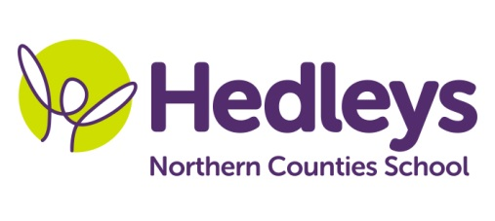
Autumn Newsletter 2020
Longsands Class
Dear Parents and Carers,
We are delighted to have the children back in school, we appreciate that they have had a long time off and need time to adjust back into the routine. We are following the updating guidelines to ensure the children’s safety. We are also following the Recovery curriculum by Barry Carpenter to concentrate on children’s wellbeing.
We will be making happiness boxes to help the children with their transition back to school. They will decorate their happiness boxes using colours, textures and items which they like. The happiness boxes will be filled with things which each individual child likes.
Our team still consists of: Pam, Lisa, Nicola, Lucy, Claire, Sarah and Kim. . We continue to have Michele McCafferty as OT and Mollie Henaghan as SaLT. We have Roz overlooking the physiotherapy whilst Steph and Caitlin have also joined the team.
Our class has stayed the same apart from one student has moved up to Rachel’s class. She will be a huge miss but we wish her well in her new class.
This term the class topic will be ‘To Infinity and Beyond’ which we have linked into a number of sessions to ensure that all senses are covered in an exciting way that will make the session much more engaging. The interactive story is ‘Back to Earth with a Bump’ where the children are taken on a journey through space and experience many new stimuli. It will be led by Mollie and Pam and we will explore various textures, smells and new resources.
We have introduced a new space themed wake up motor group with input from the physio team. The pupils will access this within their individual timetables. On Fridays the children take a journey around space in their sensory exploration session discovering the different characteristics of each of the planets. We have continued with the Music & Movement session it is currently lead by Pam and Mollie which involve a range of stretches and movements to fast, up beat music. These three sessions have certainly increased engagement within all pupils.
The hydrotherapy pool is currently closed. It will be closed for a little longer while we try to make it safe for children to use. Hopefully it will up and running by half term.
In speech and language therapy sessions peer interaction continues to be a focus to increase communication between all pupils this is done using social distancing now. In addition, pupils will be continuing to focus on the development of ICT skills in partnership with the occupational therapist. This will develop skills in the areas of switching and eye gaze.
In physiotherapy sessions we will continue to maximise the student’s physical activity throughout the curriculum including motor sessions and rebound. We are also keen to discuss and support the students being active in their home and leisure time.
In occupational therapy sessions we will continue to use the sensory room equipment, Magic carpet, seating assessments and postural assessments will be carried out for every pupil with extra cleaning procedures in place.
As always, please get in touch if you have any questions either by the home school diary, phone or email. We look forward to working with your children over the next academic year.
Best wishes, Pam, and the Longsands class team
Class teacher | OT | SALT
Pam Wiltshire p.wiltshire@percyhedley.org.uk | Michele McCafferty m.mccafferty@percyhedley.org.uk | Mollie Henaghan  m.henaghan@percyhedley.org.uk
Physio
Roz Middleton - nuth.physio.ncs@nhs.net

