Autumn Newsletter 2020-21
Beadnell Class
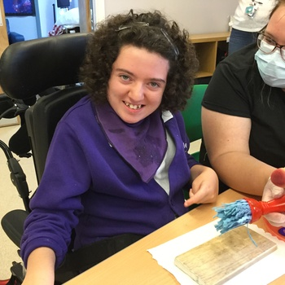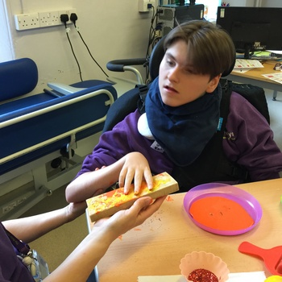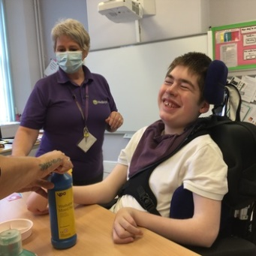
Dear Parents and Carers,
Well 2020 has been quite the experience so far! It was however, so lovely to keep in touch with you all over lockdown and shielding. I enjoyed our chats and getting to see our students at home in their natural environment.
We have all missed each other – staff and students alike, and it has been wonderful to begin to welcome everyone back. Things are a bit different in class with PPE, social distancing and lots of cleaning while remaining inside our PMLD bubble. We are hopeful that our hydro pool will be open at some point this half term following risk assessments and planning, but sadly (and understandably) we will not be venturing any further than the school grounds this term.
This term is one of recovery. The ongoing COVID situation is a stressful one for all of us. Many of our students have been out of school for a long period of time and may take time to adjust to being back. Our topic is “To infinity and beyond” which will provide many opportunities to explore and create. Communication, building and maintaining physical skills and sensory exploration will remain integrated throughout all daily sessions although at a more relaxed pace initially and as always we will be led by our students and yourselves.
We will welcome a new speech and language therapist later this month, and I’m sure Erin will introduce herself to you all once in post. Our class occupational therapists are Michele McCafferty and Anna Sallows, and we have Steph Brown and Rosalind Middleton as our physiotherapists. We also look forward to the arrival in class of 2 new students, one having almost moved to us from Pam’s class before lockdown.
We know you will have concerns and wobbles at times over this autumn term, but please be reassured that the safety and wellbeing of the students is our priority,
Please don’t hesitate to contact us by phone, or on the below emails
Best wishes, Rachel, Julia and the Beadnell class team
Class Teacher | OT | SALT
Rachel Jeffares  r.jeffares@percyhedley.org.uk  Julia Patterson  j.patterson@percyhedley.org.uk | Anna Sallows  a.sallows@percyhedley.org.uk  Michele McCafferty  m.mccafferty@percyhedley.org.uk | Erin Kelly  Erin.kelly@percyhedley.org.uk
Physio - on referral
Steph Butler / Roz Middleton - nuth.physio.ncs@nhs.net

