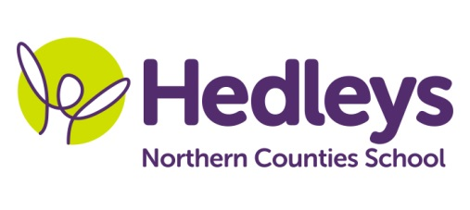
Autumn Newsletter 2020-21
Hadrian Class
Dear Parents and Carers,
We are delighted to be welcoming the children back to school and begin a new year of learning! Obviously, it is very unusual times at current but we are prepared to support all of our children in overcoming the challenges that we are all facing.
We have put in place a restorative timetable which means a gradual return to our usual routines and lessons over the course of a number of weeks rather than diving straight into a full timetable. This allows us to ensure the children’s mental and physical wellbeing as they return to school following a turbulent period.
To this end, we are focussing on exploring mental wellbeing this half term, looking at our emotions and how we can manage these using a wide variety of calming strategies – many of them continuing their work with our class occupational therapist.
Maths and English will return in their usual form in addition to a new lesson on the timetable – Reading. We are placing a focus on reading skills this year to encourage children to develop their language even further. Reading lessons will consist of a number of different activities that will be regularly repeated to help children retain what they have learned. Myself and the support staff will read on a one-to-one basis with your children daily and support them to complete tasks related to the book they are reading. We hope this will have a big impact on your child’s reading skills in the months and years to come.
In Maths, some of our children will be revisiting number and place value and develop their knowledge of numbers up to 1,000. This is a significant step in their maths knowledge as it will enable them to identify any number between 0 and 1,000. Other children will be looking at numbers and identifying tens and ones in a range of different contexts with the hope of being able to count to 100.
In English, we will be focussing on stories and poems this half term, in particular acrostic poems based on a topic chosen for them. They will then progress through writing poems on different topics before choosing their own.
In other subjects, we will be looking at maps and atlases in Geography while in RE, we will learn more about Christianity and the Bible. We will also be beginning to learn about the world of work in Careers. Maria Mawdesley, Sam Dowling, Lauren Tate and Claire Balmforth will continue their work with the children in IT, DT, Art and BSL respectively.
We hope that your children will enjoy their return to school and benefit from the daily routine in these difficult times. As ever, if there is anything you wish to discuss, feel free to contact us and we will do our best to help.
Best wishes, Callum and the Hadrian class team
Class Teacher | OT | SALT
Callum Fox  callum.fox@percyhedley.org.uk | Julie Osborne  j.osborne@percyhedley.org.uk | Catrin Jones  catrin.jones@percyhedley.org.uk
Physio - on referral
Steph Butler - nuth.physio.ncs@nhs.net

