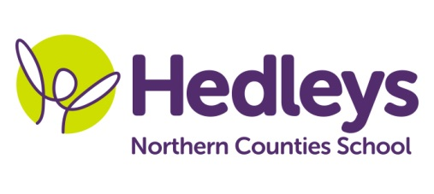
Spring Newsletter 2019-20
The Armstrong Centre – Tyne Class
Dear Parents and Carers,
Happy New Year to you all. I hope you all had a lovely Christmas and did not over indulge too much!!! It was lovely to hear all about the pupil’s holiday news and what their favourite presents were.
We have a very busy term ahead where our Overall Topic is ‘Superheroes with a theme based around comic book characters and the emergency services
Our literacy focus will be familiarising ourselves with key stories and comic book heroes such as ‘Supertato’ and non-fiction books which are structured in different ways such as Grace Darling and Emergency services books; where pupils will extend their vocabulary using their preferred means of communication to complete the tasks such as speech, PECS, VOCA, BSL signing, writing or a combination. Pupils will also continue to work on their individual programmes.
Our main focus within Numeracy will be to develop skills in number, place value and time and in identifying and using money in practical situations. Within science sessions we will be exploring the topic of ‘Forces’. Pupils will be working scientifically to make a selection of superhero gadgets and perform simple tests using suitable equipment.

Pupils will continue to participate in community links such as local hospitals and police and fire stations.
In speech and language therapy sessions we will be continuing to develop communication skills using each child’s preferred communication method using a Total Communication Approach. We will continue to use approaches such as Narrative Therapy, Colourful Semantics and Intensive Interaction throughout a variety of sessions including Shopping, LEGO therapy, Swing room sessions, Narrative Sessions and interactive story sessions
In occupational therapy sessions we will be focusing on self-regulation, increasing independence and developing our social skills in sessions such as the swing room, sensory story, food technology, Lego therapy and community shopping.
The end of the topic will see the Hillcrest centre coming together to compete in the Enrichment competition where each class will design and make a costume for a superhero day and participate in a superhero Treasure hunt. So as you can see we have another busy term ahead of us.
If you have any further questions please don’t hesitate don’t hesitate to contact us on
Best wishes,
The Armstrong centre – Tyne class.
Class Teacher | OT | SALT
Carol Rawlinson  crawlinson@percyhedley.org.uk | Shauna Garrity s.garrity@percyhedley.org.uk | Carra-Lynn Lindsey c.lindsay@percyhedley.org.uk
Physio
NHS team on referral
Don’t forget there will be a photographer onsite on Tuesday 28th January to take school photos of our students.

