Spring Newsletter 2019-20
Penshaw Class
Dear parents and carers,
It was lovely to see everyone back in school at the start of January ready for the new spring term and we hope everyone has enjoyed the Christmas break.
Last term we were very busy working towards our certificates as well as experiencing lots of different work place opportunities.
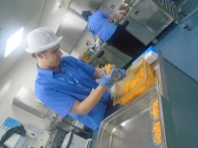
Oliver visited North Tyneside Hospital each week to work in the catering department; he helped to prepare the trays and visited the wards to help serve the meals.
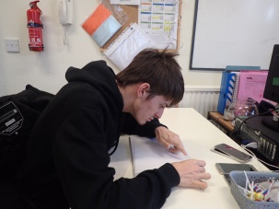
David took lots of photos for his work experience. He downloaded them and printed them out to be used in letters and leaflets.

All the students enjoyed Careers Week. We had visitors from The Bell group who gave a presentation about career opportunities in their organisation, visitors from Dance City also came into school and we had great fun joining in their workshop.

We are planning lots of exciting visits to help us with our lessons; learn about colleges and future careers.

Please feel free to contact the team at any time,
Best wishes
Julie Clark and the Penshaw class team

Class teacher | OT | SALT
Julie Clark  j.clark@percyhedley.org.uk | Julie Osborne j.osborne@percyhedley.org.uk | Poppy Welsh p.welsh@percyhedley.org.uk
Physio
NHS team on referral

Don’t forget there will be a photographer onsite on Tuesday 28th January to take school photos of our students.

