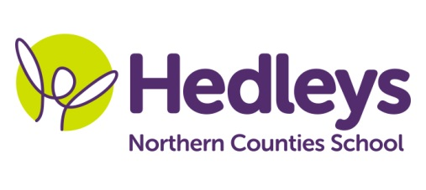
Spring Newsletter 2019-20
Hadrian Class
Dear Parents and Carers,
We hope that you have all enjoyed a very merry Christmas and a happy new year as children return to school this month.
Our topic for this term is titled ‘Healthy Living’ and we will be learning about the importance of keeping ourselves healthy and how we can achieve that.
In English, we will be looking at how to write a set of instructions which will tell another person how to carry out a set task. The children will be writing a set of instructions on a number of topics, including how to cross a road safely.
In Maths, children will continue to develop their knowledge of addition and subtraction, including how to use the column method to add and subtract two-digit numbers and then learning how to exchange effectively in situations where we may need to borrow or carry a number.
For humanities this term, we will be focussing on RE where we will be researching about a major world religion in Islam. Children will be using computers to help with their research and deliver a PowerPoint at the end of term about what they have learned about Islam.
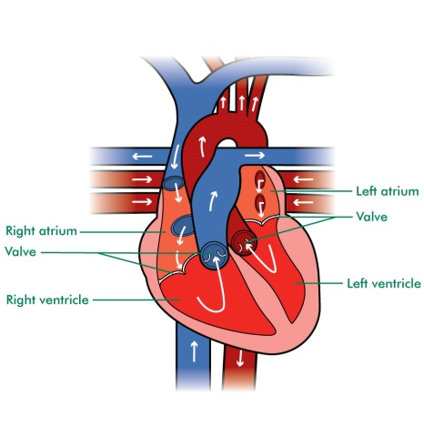
Our topic name comes from what we will be looking at in Science, as we will be learning about how to live healthily. We will learn about healthy and unhealthy food, the importance of hygiene and why we need to exercise to keep ourselves healthy. We will also look at the heart and the role it plays in our body.
Poppy, our speech and language therapist will continue her work with the children on their individual programmes developing their language and communication skills. Poppy will also be continuing her work with the children in improving their comprehension skills.
Claire will continue to teach BSL throughout the term and Lauren will also be helping the children learn literacy through the use of arts and crafts.

It promises to be an exciting start to a new year! As ever, if there is anything you wish to discuss, feel free to contact us and we will do our best to help!

Best wishes

Callum and the team at Hadrian Class.

Class teacher | OT | SALT
Callum Fox  callum.fox@percyhedley.org.uk | Julie Osborne  j.osborne@percyhedley.org.uk | Poppy Welsh p.welsh@percyhedley.org.uk
Physio
NHS team on referral

Don’t forget there will be a photographer onsite on Tuesday 28th January to take school photos of our students.

