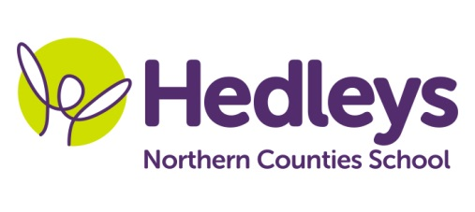
Spring Newsletter 2019-20
Ford Class
Dear Parents and Carers,
I hope you had a lovely time during the Christmas holidays.
Our topic this term is Superheroes. We will be doing a range of activities associated with Superheroes during Forest School and Science, listening to the ‘Superworm’ story and making grass pot superheroes, superhero masks, superhero figures, superhero salt dough faces, superhero hand cuffs and superhero shields decorated and made out of leaves, twigs and flowers for forest school. For Science we will be listening to the ‘Superworm’ story again and we will be making crafts and we will perform simple tests associated with forces, for example static electricity butterfly experiment, sparkly explosion experiment, float and sink test experiment, magnetic force test experiment, as well as making balloon rockets and toilet roll airplanes. For RE we will be focusing on signs of different religions and we will be watching a power point presentation/story of a specific religion and then we will be making the sign of the specific religion of the week using a variety of resources and materials. Numeracy will be based on a variety of topics like numbers, measure, shapes and time and we will be doing lots of fun and interesting activities.
Every Monday morning we will be going shopping to get the ingredients for the superheroes’ favourite food ’cake in a mug’ that we will be making for Food Tech. Students will be learning how to follow a method for a recipe, fine motor skills when chopping ingredients and discussing what ingredients they need to add to make a dish.
Every Friday afternoon we will be going to the Tim Lamb centre and we will have lots of fun and playing lots of games.
This term we will be focusing on the story of ‘Charlie the firefighter’.
Within our communication in the community sessions, our students we will be accessing shops in the local area and the cafe to promote independence, which focuses on developing appropriate social skills within daily living tasks
As a class we will be continuing to focus on communication; pupils will have the opportunity to practice their communication skills and use their preferred methods in class and with peers and also within communication and community access sessions with our speech and language therapist Nicola.
In occupational therapy sessions with Doug we will be doing lots of sensory integration activities, including relaxation techniques, magic carpet, sensory room, as well as food exploration.
Pamela will continue to teach music
If you have any further questions you would like to discuss please don't hesitate to contact me.
Ilianna and the Ford class team
Class teacher | OT | SALT
Illiana Katsavria  i.katsavria@percyhedley.org.uk | Doug McQuillin d.mcquillin@percyhedley.org.uk | Nicola Leonard n.leonard@percyhedley.org.uk
Physio
NHS team on referral

Don’t forget there will be a photographer onsite on Tuesday 28th January to take school photos of our students.

