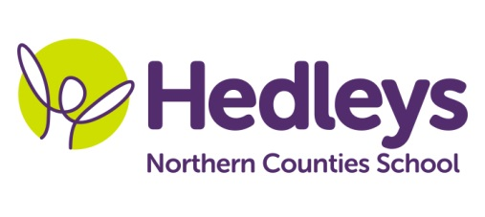
Spring Newsletter 2019-20
Embleton Class
Dear Parents and Carers,
I hope you had a lovely Christmas holiday and a very Happy New Year! Welcome back to all the students, we have another busy term ahead!
We had a fun packed Autumn term and all the students settled back into their routine well. We had a very busy festive period and I couldn’t resist including some pictures below! This term our team remains largely unchanged and the students continue to be supported by Sharon, Amy, Charlotte, Christina, Rebecca and Jill. We welcome Nikita who will support students Wednesday – Friday. I continue to work alongside Ashleigh, Michele and Gemma to integrate therapy into all sessions.
This term the class topic is “cooking” and we are planning a culinary tour of the world; USA, China, Central Asia, Italy and the UK. We will be exploring different textures and smells as part of this and hope to start a weekly cookery session as part of our sensory exploration.
We will focus on the following areas of learning:
- Exploring the senses through cookery – I hope our weekly sessions will engage the students through their different senses, prompting different responses and providing opportunities for meaningful communication.
- Promoting turn taking – we have had an increased focus on peer interaction and we would like to build on this by reinforcing turn taking as much as possible across the curriculum. This supports the students to recognise their name within a group setting.
Our speech and language therapy sessions continue to focus on social games and turn taking and a sensory story. This term the sensory story will link to our cookery topic visiting lots of different places and encouraging students to demonstrate preferences.
In occupational therapy sessions we will be continuing to access IT and developing skills in ICT. We will be supporting the students to access the cookery sessions looking at hand function and access so they can fully participate in the sessions.
In physiotherapy sessions we will continue to work towards our individual motor targets and participate in group games, integrating our therapy into our daily work. Rebound and hydrotherapy continue to be favourite sessions for many students; we are continuing to reinforce communication throughout these sessions.
As always, please do get in touch if you have any queries or questions via the home/school diary, phone, email (r.field@percyhedley.org.uk) or by popping into school.
Best wishes,
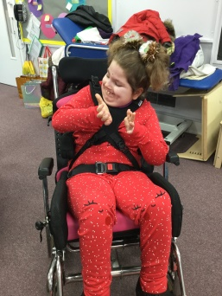
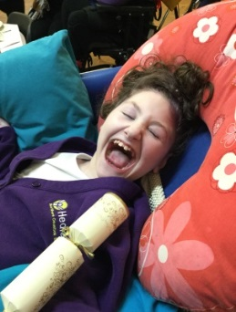
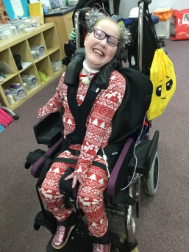
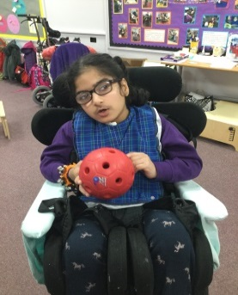
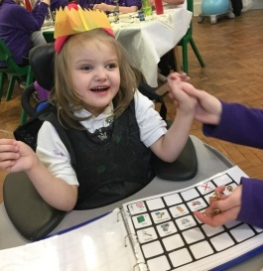
Ros and the team
Don’t forget there will be a photographer onsite on Tuesday 28th January to take school photos of our students.

