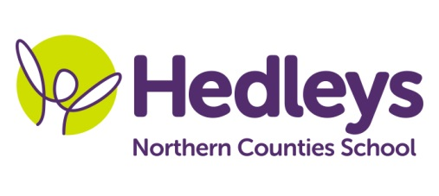
Autumn Newsletter 2019-20
Angel Class
Dear Parents and Carers,
Welcome back everyone, I seem to have blinked and the six weeks have gone!
Firstly let me start by introducing myself. I am Helen Blakelock and I am the new class teacher. For some of you we have already met, but for those who haven’t yet I have been working as a Teacher of the Deaf at Northern Counties School for thirteen years now. I am excited to be given the opportunity to work with your young person for the foreseeable future and look forward to meeting you all properly soon.
The support staff within the class team have stayed the same this year and we will be continuing to work with Emily our Speech and Language therapist and Julie and Anna our Occupational therapists. We are lucky this year to have Maria Maudsley, a specialist computing teacher from Percy Hedley school, taking our computing sessions and Claire Atkinson giving a focused careers session and organising work experience for our students.

This term the class topic will be Transport
We will focus on the following areas of learning:
- Literacy/Art – being creative with the novel James and the Giant Peach
- Numeracy – focus on measurement, time and money
- Science – forces
- History/ASDAN – the history of transport
- RSE – relationships and exploring our own bodies
Our therapists will continue their vital input working towards our ASDAN Personal progress
as well as our SMiLE unit of using the metro.

Please don’t hesitate to contact us at school with any questions or even just for a chat
on 0191 2815821 or the emails listed below
Thanks
Helen and the Angel class team

Class teacher | OT | SALT
Helen Blakelock h.blakelock@percyhedley.org.uk | Anna Sallows  a.sallows@percyhedley.org.uk | Poppy Welsh p.welsh@percyhedley.org.uk
Physio
NHS team on referral

Don’t forget there will be a photographer onsite on Tuesday 28th January to take school photos of our students.

