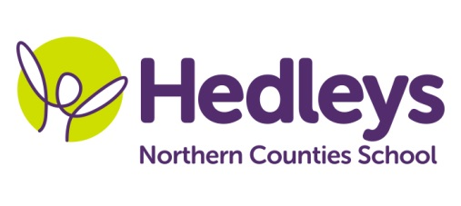
Spring Newsletter 2019-20
Alnwick Class
Dear Parents and Carers,
I hope you all had special Christmases with your lovely children. We have had such a lovely term. We upload photos of the children regularly onto Earwig Academic and I hope you enjoy looking to see what your child has been learning about. If you haven’t yet logged on, please do have a look! Any problems with Earwig, please let us know as we do enjoy sharing the children’s learning with you.
In Play Skills children have practised turn taking and peer interaction both with table top games, and in the sports hall with the parachute and tug of war. In Forest School we have really enjoyed making Christmas crafts, sitting together to share the equipment and listening to Christmas songs. I hope you loved your reindeers and wreathes!
This term our topic is Superheroes, with a focus on the emergency services. We will be learning about the police, fire brigade and health services. In Science we will be carrying out a range of Superhero themed experiments with an emphasis on using PECS / speech / BSL to comment on what we observe. We will also be learning about seasonal changes as they happen.
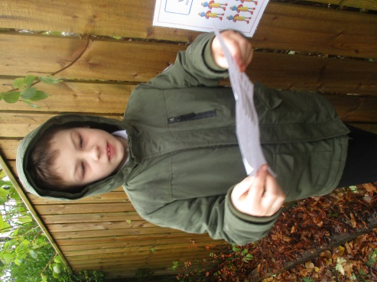
In maths we have been carrying out individual tasks and getting out and about to do maths treasure hunts (Christmas themed ‘more’ or ‘less’!). Next term we will continue to learn about number but will also review previous learning on time – days, weeks, months, years, day, night – and shape. We will also be using money in practical senses when out in the community.

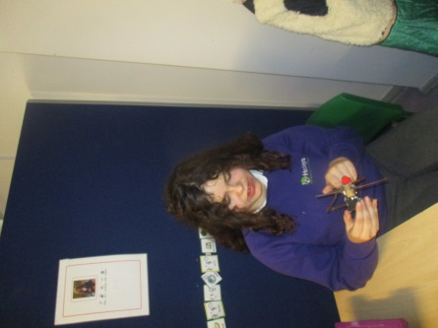
This term the children planted hyacinth bulbs, caring for them before selling them at the Christmas Fair. We watched them grow and noticed the roots that had developed. We sent a bulb home with each of the children and hopefully they flowered over the Christmas holidays. Let us know how they turned out and what colour!

We will continue to access lots of community based learning in the next term. Each Monday morning, pupils will visit Tesco in order to purchase the items required for their Food Tech lesson. On Thursday afternoon we will be visiting cafes in Jesmond and pupils will continue to develop their communication skills as appropriate to their individual targets. On Tuesday afternoons we will be visiting various local places of interest. Please make sure that children come to school with clothing suitable for the weather and comfortable shoes for walking outside.
Our swimming lessons will take place on Tuesday mornings, please send pupils to school with a swimming costume and towel. We will be having PE on a Friday afternoon. This term we have been developing our ball skills and carrying out sensory circuit activities in the sports hall.
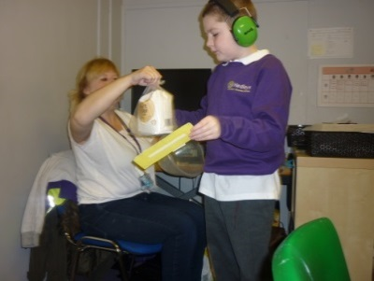
Shauna continues as our class OT and Mollie as our class SALT. Shauna will be leading fine motor skills each week and will also continue with Baking Therapy. Children have the role of ‘Instructor’, ‘Supplier’ and ‘Baker’ using red / green boards to follow instructions. Children use PECS to instruct and request items, choosing the correct item from a choice of two.

Mollie delivers one of our Communication sessions and our weekly Interactive story. This term our story has been about the circus and next term’s Interactive Story will be ‘Room on the Broom’
We will continue to develop each pupil’s individual communication skills, social skills and relationships through their preferred method of communication (verbal, sign, PECS and gesture) across the curriculum.
Please don’t hesitate to contact me should you have any questions, concerns or wish to share information about your child.
Janice March and the Alnwick class team
Class | OT | SALT
Janice March j.march@percyhedley.org.uk | Shauna Garrity s.garrity@percyhedley.org.uk | Mollie Henaghan m.henaghan@percyhedley.org.uk
Physio
NHS team on referral

Don’t forget there will be a photographer onsite on Tuesday 28th January to take school photos of our students.

