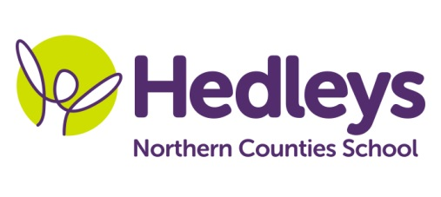
Autumn Newsletter 2019-20
Embleton Class
Dear Parents and Carers,
Welcome back to school for another busy year! I hope you all had a fantastic summer holiday and were able to get out and about in the changeable weather!
I am looking forward to another year teaching this class and we welcome a new student this September; and we are a class of all girls again! Our support team remains much the same with Kim as our higher level special support assistant alongside other support staff: Amy, Charlotte, Rebecca, Christina and Jill. We also welcome Inna who will be working in our class on Fridays. Our therapy team remains unchanged with Michele McCafferty (OT), Ashleigh Richardson (SaLT) and Gemma James (physio) all continuing to be actively involved in planning and delivering our sessions. This term the class topic is people who help us and we are going to start by focusing on those people closest to us; family, friends and school staff. We plan to make paper chains of the people around us as well as a school tree including input from everyone we work with in school.
We will focus on the following areas of learning:
- Continuing peer interaction – we made some excellent progress last term with peer interaction and it was lovely to see all the learners showing increased interest in their peers. This will enable us to give a warm and friendly welcome to our new pupil!
- Thinking about emotions – as part of our topic “people who help us”, we are also going to consider how we can help ourselves and look after ourselves. This will involve considering how different sessions make us feel and encouraging everyone to express likes and dislikes as much as possible.
In speech and language therapy sessions we will continue to explore different games as a group and promote peer interaction. We have some new inflatable turn taking games to explore. We will also be updating our sensory story to think about different people who help us.
In occupational therapy sessions we will be continuing to access IT and developing skills in ICT. We will be working in collaboration with the therapist and teaching staff to support the topic “people who help us”.
In physiotherapy sessions we will continue to work towards our individual motor targets and participate in group games, incorporating the learning areas where possible. Rebound and hydrotherapy continue to be favourite sessions for many students, and we will be including communication targets into all of our programmes!
As always, please do get in touch if you have any queries or questions via the home/school diary, phone, email or by popping into school. I am looking forward to another fantastic year working with your young people!
Best wishes,
Ros and the Embleton class team
Class | OT | SALT
Ros Field r.field@percyhedley.org.uk | Michele McCafferty m.mccafferty@percyhedley.org.uk | Ashleigh Richardson a.richardson@percyhedley.org.uk
Physio
Gemma James – Gemma.James@nuth.nhs.uk

