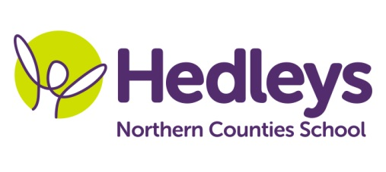
Autumn Newsletter 2019
Angel Class
Dear Parents and Carers,

Welcome back, we have all been really pleased to see the children back at school full of smiles and enthusiasm following our summer break.
We’ve given a huge welcome to a new pupil in our class this academic year and all the students have enjoyed getting to know their new friend and have worked really well together both in the classroom and at playtimes this week.

Staff working in our class this term are Penny (Teacher of the Deaf) Nichola (HLTA), Laura, Michelle and Claire (SSAs). Claire is also our BSL tutor, Pamela (music teacher)
Kerry (PE/swimming tutor), Lauren (art teacher), Poppy (Speech and Language Therapist) and Anna (Occupational therapist) ’
Our topic this term is ‘All about me and my school’ which will help us find out about ourselves, each other and how we are different or the same to other people. Claire has already started us on our BSL lessons where she will be exploring deaf history and identity. Anna will also be in class regularly helping us input our OT targets into all areas of the curriculum

In literacy we will be working on our communication, BSL, developing our reading and writing, and signing/reading the traditional tale ‘the enormous turnip’. We will be making our own books linked to topic work and having lots of fun learning with Lauren through a variety of English/art projects. Poppy is continuing to work with us in both group language and also individual sessions supporting us in our expressive and receptive skills.

In maths we will continue working at our own individual pace with our knowledge of number and we will also be having lots of fun using the outdoor environment to explore money/numbers in context. We will also be using comparison vocabulary and using a variety of practical activities learning about time and measure.

In science we will be developing our investigations skills using our 5 senses having lots of practical learning with smell/taste tests and feely boxes. Kerry has lots of apparatus and physical challenges set up for us and Pamela will be teaching us lots of new songs and dances. In Humanities we will be finding out about the famous landmarks in and around Newcastle and looking at how we have changed from babies to now.

As you can see we already have lots planned. We are all looking forward to this autumn term and we are planning to keep the children really busy learning lots of new things.
If there is anything you wish to discuss please feel free to contact me – telephone or email.

With best wishes

Penny and the Angel class team

Class teacher | OT | SALT
Penny Johnson  p.johnson@percyhedley.org.uk | Anna Sallows a.sallows@percyhedley.org.uk | Poppy Welsh p.welsh@percyhedly.org.uk
Physio
NHS team on referral

