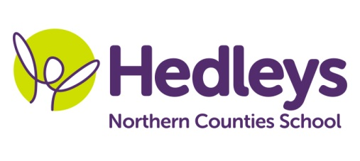
Autumn Newsletter 2019-20
Alnwick Class
Dear Parents and Carers,
I hope that you have all had a lovely summer holiday! I am delighted to start my new role at Northern Counties School and I am enjoying getting to know, and build relationships with, your lovely children. This year our class team has John as HLTA and or SSAs are Gemma, Anne, Julie and Ru. We also have some new SSAs: Lyndsey, Carole, Heather, Louise and Lynne.
Over the summer holidays a new play area has been built in the area outside of our classroom. This area is to allow pupils opportunities to support their regulation throughout the day. It is a lovely space, including a sunken trampoline, 2 basket swings and a bridge / tunnel. As you can imagine, the new area is being very much enjoyed!
This term our topic is European Festivals. We will be learning about some of the different festivals that take place in Europe, including St Patrick’s Day, the Kettlewell Scarecrow Festival, the Flower Carpet in Brussels, Catalonia’s Les Festes de la Mercè and Germany’s 200 year old Oktoberfest!
In Science we have been learning about the changes that come with autumn and searching for conkers, berries, other tree seeds and autumn leaves in the school grounds. We have a very fine crop of blackberries around the grounds at the moment!
We will continue to access lots of community based learning. Each Monday, pupils will visit Tesco in order to purchase the items required for their Food Tech lesson following our shopping trip. On Thursday afternoon we will be visiting cafes in Jesmond and pupils will continue to develop their communication skills as appropriate to their individual targets. On Tuesday afternoons we will be visiting various country parks and woods. Please make sure that pupils come to school with a coat and comfortable shoes for walking.
Our swimming lessons will take place on Tuesdays, please send pupils to school with a swimming costume and towel. We will be having PE on a Friday morning.
Shauna continues as our class OT and we are joined this year by Mollie as our class SALT. Shauna will be leading fine motor skills each week and will also continue with Baking Therapy which involves children working in groups to communicate instructions, collect ingredients and make various food items / smoothies. We will also continue to develop social and communication skills with our weekly Play Skills lesson.
We will continue to develop each pupil’s individual communication skills, social skills and relationships through their preferred method of communication (verbal, sign, PECS, VOCA and gesture) across the curriculum.
I hope to meet everyone in person before too long. Please don’t hesitate to contact me should you have any questions, concerns or wish to share information about your child.
Janice March and the Alnwick class team
Class | OT | SALT
Janice March j.march@percyhedley.org.uk | Shauna Garrity s.garrity@percyhedley.org.uk | Mollie Henaghan m.henaghan@percyhedley.org.uk
Physio
NHS team on referral

