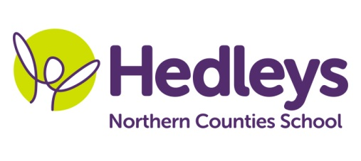
Autumn Newsletter 2019-20
Ford Class
Dear Parents and Carers,
I hope you had a lovely time during the summer holidays.
Our topic this term is Asia. We will be doing a range of activities associated with Diwali during Forest School and Art making salt dough diva lamps, leaf luminaries, flame crafts, mandalas and rangoli. For RE we will be focusing on festivals of light like Santa Lucia and Hanukah making lots of crafts. For Science we will be focusing on the ‘’Little Acorn’’ story and its adventures to become an oak tree. We will also be learning about the life cycle of various animals and making lots of crafts about it. Numeracy will be based on a variety of topics like numbers, measure, shapes and time and we will be doing lots of fun and interesting activities.
Every Monday morning we will be going shopping to get the ingredients for our Food Techology sessions. Students will be learning how to follow a method for a recipe, use fine motor skills when chopping ingredients and discussing what ingredients they need to add to make a dish.
Every Friday afternoon we will be going to the Tim Lamb centre and we will have lots of fun and play lots of games.
This term we will be focusing on the story of Mulan.
Within our communication in the community sessions, our students we will be accessing shops in the local area and the cafe to promote independence, which focuses on developing appropriate social skills within daily living tasks
As a class we will be continuing to focus on communication and pupils will have the opportunity to practice and progress their communication skills daily by using their preferred method of communication. Nicola, our speech and language therapist, will continue to assist our communication and community access work.
In occupational therapy sessions with Doug we will be doing lots of sensory integration activities, including relaxation techniques, using the magic carpet and visiting the sensory room as well as food exploration.
Jess will be doing a body awareness session during intensive interaction.
Pamela will continue to teach music and Kerry will be teaching PE within our class.
If you have any further questions you would like to discuss please don't hesitate to contact us.
Thank you
Ilianna, Jess, and the Ford class team
Class teacher | OT | SALT
Illiana Katsavria  Jess Prince  i.katsavria@percyhedley.org.uk  j.prince@percyhedley.org.uk | Doug McQuillin d.mcquillin@percyhedley.org.uk | Nicola Leonard n.leonard@percyhedley.org.uk
Physio
NHS team on referral

