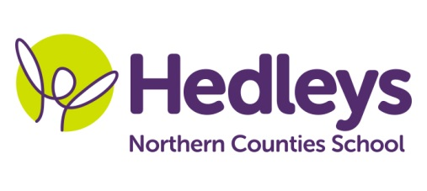
Autumn Newsletter 2019-20
Dunstanburgh Class
Dear Parents and Carers,
Hope you all had a lovely summer! It has been lovely seeing all the students back in school after the holidays. We have had a busy couple of weeks settling into our new classroom and meeting new friends and staff.
Our topic this term is ‘The America’s Food and Festivals’ and this theme will be running throughout the curriculum including ASDAN and art. This will include learning all about Mardi Gras and Thanksgiving through crafts, food preparation and music.
We will focus on the following areas of learning:
- Preparation for adulthood, which will include individualised work related learning
and enterprise programmes.
- Individualised life skills and independence programmes.
- Community and social interaction, with many opportunities to visit different places in
the community including local cafes, leisure centres and work related learning
taster sessions.
- Accreditation; this year we are continuing to use ASDAN for our formal accreditation.
This will include a mixture of ‘Towards Independence’ modules and ‘Life Skills challenge’.
Our speech and language therapist, Emily, is getting to know the class and will continue to work on individualised programmes with the students using their preferred method of communication (PECS, symbol support, spoken language). This may take place on an individual basis and/or through group sessions, such as baking therapy - where students are supported and encouraged to interact with each other to carry out and cook from a recipe.
In occupational therapy sessions, Gemma will continue to support students on their life skills, independence and behaviour for learning within everyday contexts. OTs will be working on therapy throughout the curriculum, such as in food technology as well as on a 1:1 basis.
Both speech and language therapy and occupational therapy will continue to be provided on a needs led basis for each student, which will be reviewed as appropriate throughout the year.
Please don’t hesitate to contact us on 0191 2815821 or the below email addresses if you require any further information.
Best wishes,
Claire and the Dunstanburgh class team
Class teacher | OT | SALT
Claire Atkinson  claire.atkinson@percyhedley.org.uk | Gemma Cooke g.cooke@percyhedley.org.uk | Emily Searle emily.searle@percyhedley.org.uk
Physio
NHS team on referral

