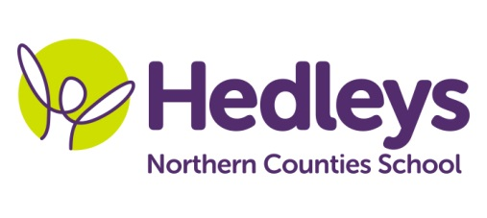
Autumn Newsletter 2019-20
Tyne Class
Dear Parents and Carers,
It was lovely to see the pupils back after the summer break and to welcome those new pupils joining us.
This year our team is Carol Rawlinson (Teacher), Shauna Garrity (OT), Carra-Lynn Lindsay (SaLT), Evie Malholm (HLSSA), Joanne Collins (SSA), Kirsty Knott (SSA) and Emma Rogers (SSA) and we have a new class name – Tyne Class.
Our overall topic this term is Festivals around the world with an emphasis on Asia. Within English sessions pupils will be familiarising themselves with key stories and stories from other cultures. We will be developing reading and writing skills throughout the topic as well as following their own individual programmes.
Science sessions this term will see pupils following the life cycle of butterflies. They will grow their own butterflies and record what they see at each stay of development using a variety of specialist equipment throughout the topic.
Maths sessions will be developing pupil’s individual skills within number, place value and measurement. Pupils will continue to develop their money skills through practical situations such as weekly shopping tasks where they will purchase items on their shopping list to use in food technology sessions and for break times.
Out and about humanity sessions will be on Thursday afternoon so appropriate clothing and footwear will be required.
Within joint therapy sessions such as community shopping, lego therapy and sensory story, students will be working with both the Speech and Language Therapist and Occupational Therapist to develop their social communication skills and explore a wide range of sensory platforms.
If you have any further questions you would like to discuss please don’t hesitate to contact us.
Best wishes,
Carol and the Tyne class team

Class Teacher | OT | SALT
Carol Rawlinson  crawlinson@percyhedley.org.uk | Shauna Garrity s.garrity@percyhedley.org.uk | Carra-Lynn Lindsey c.lindsay@percyhedley.org.uk
Physio
NHS team on referral

