Autumn Newsletter 2019-20
Hadrian Class
Dear Parents and Carers,
Welcome to a new school year, we are delighted to see that all of the children have enjoyed their summer holidays and are back ready to learn!
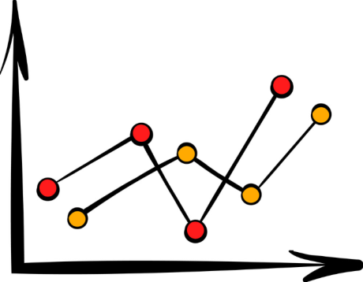
Our topic this term is ‘All About Me’ where we will learn about ourselves as people and how our bodies work. In literacy, we will develop our writing skills through learning about autobiographies and life stories. The children will be writing about themselves and their lives and build up to writing an autobiography based on their own life so far!
In mathematics, we will be looking at graphs and data collection. Students will learn how to collect data and display it using graphs and charts. We will also be working to review our knowledge of addition, subtraction, multiplication and division.

Humanities lessons will begin this term with a look at Hadrian’s Wall, which has inspired our new class name for this year – Hadrian Class.

In Science, we will be learning about evolution and inheritance – looking at how families share things in common and pass on traits to children. We will also look at how our bodies work and what things are essential to our survival.
Poppy, our speech and language therapist will be continuing her work with the students on their individual programmes developing language and communication in different settings and situations. Poppy will also be looking at developing language used for thinking and questioning skills this term.

BSL lessons will continue with Claire to help improve student’s communication skills. Lauren will also be helping the children learn literacy through the use of arts and crafts in her sessions.

We have plenty of exciting activities and experiences planned and we are looking forward to sharing them with the class! If there is anything you wish to discuss, feel free to contact us and we will do our best to help!

Best wishes
Callum and the team in Hadrian Class.
Class teacher | OT | SALT
Callum Fox  callum.fox@percyhedley.org.uk | Julie Osborne  j.osborne@percyhedley.org.uk | Poppy Welsh p.welsh@percyhedley.org.uk
Physio
NHS team on referral

