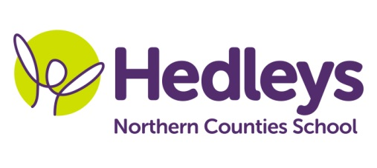
Spring Newsletter 2018-19
Dear Parents and Carers,
Welcome back for the Summer Term – I can’t believe how fast this year has gone! I hope you all had a lovely Easter holiday and the students are all relaxed and ready for another busy term.
We have had a few changes in our team this year and last term we welcomed Rebecca Lowes and Christina Madin to our class. Both girls have settled in well and have worked hard at getting to know our class. We continue to work closely with Michele McCafferty (OT), Ashleigh Richardson (SaLT) and Gemma James (physio) to ensure all the students are getting the maximum benefit out of their time in school. We are fortunate to continue receiving support from Pamela McGahon (music teacher), Lauren Tate (art teacher), Steph Richards (SaLT assistant) and Michelle Lisgo (OT assistant).
This term the class topic is the weather and we will be exploring all different types of weather in class – water spray rain, cloud dough snow and fans blowing wind. Hopefully the British summer will not let us down and we will be able to get out and about in the grounds to explore the different weathers!
We will focus on the following areas of learning:
- The magic room – the sensory room has now been fitted with new “magic room” technology where one central programme controls all the different pieces of equipment. This means we can change the room to experience different extreme weather (without actually getting wet of course!)
- Peer interaction – it has been lovely seeing the students all engage together through group activities and incidentally in pairs throughout the day. This will continue to be a priority for us in the coming term.
In speech and language therapy sessions we will continue to explore different games as a group and promote peer interaction. In the spring term we especially liked using the bubble machine and some scented foam! We will also be updating our sensory story to explore different types of climate and will visit Antarctica, South America, the Sahara and the UK.
In occupational therapy sessions we will be exploring the sensations associated with different weather as part of our on-going hand function work. We will also be looking to incorporate weather programmes into our technology work, whether through the eye gaze, touch screen, iPad or interactive whiteboard.
In physiotherapy sessions we will continue to work towards our individual motor targets and participate in group games. Rebound continues to be a favourite session for many students! We will also continue to access changes of position as needed throughout the day.
As always, please do get in touch if you have any queries or questions via the home/school diary, phone, email (r.field@percyhedley.org.uk) or by popping into school. We are all looking forward to another fantastic term working with your young people!
Best wishes,
Ros and the team

