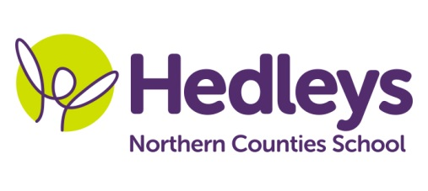
Spring Newsletter 2018-19
Dear parents and carers,

We hope everyone has enjoyed their Easter Break following our very busy spring term. The students took part in many exciting and challenging activities throughout the term.

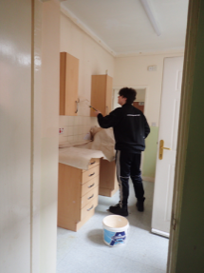
One of our students enjoyed his work experience placement as a painter and decorator with the Mears organisation.

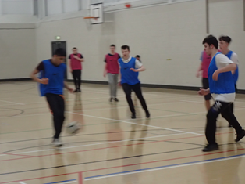
A group from our class and some from Mairead’s class went to Percy Hedley School to participate in a course leading to a certificate in Football Coaching.

The whole group enjoyed visits to different working environments. They found the visit to the Formica factory very interesting.

All of the students have taken part in the Young Enterprise sessions. They have researched, planned, made and sold various items. We have made a considerable profit and will be thinking about our next production line.

For the summer term, as well as continuing to explore further opportunities to go out into the community, students will be focussing on completing external accreditation courses in English, maths and Asdan.

Please feel free to contact the team should you have any queries or concerns.

j.clark@percyhedley.org.uk

Julie Clark
14 to 19 team

