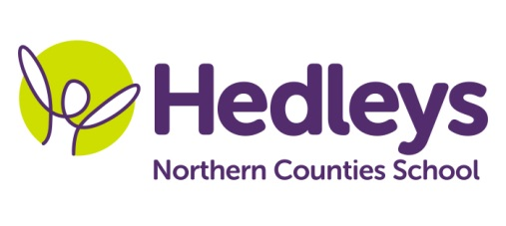
Spring Newsletter 2018-19

Dear Parents and Carers
Welcome back and I hope you all had an amazing Easter. The team have really enjoyed listening to what you and your children have been doing over the Easter holidays.
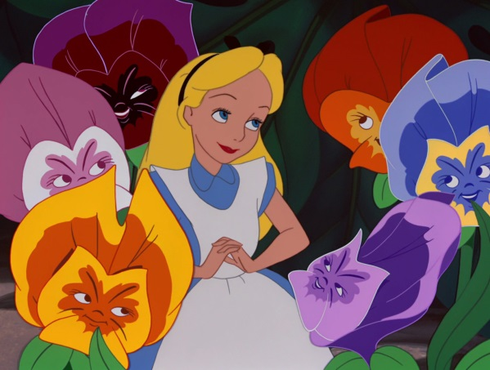
Our topic this term is the work of Julia Donaldson and Alice in Wonderland. We will be doing a range of activities associated with this topic including going on community access trips to different woodland areas, writing about different characters from the story, art based around the topic and the students will be learning about plants

As a class we will be continuing to focus on communication and pupils will have the opportunity to practice communication skills within break and lunchtime periods and within communication, community access and social skills sessions with assistance from our speech and language therapist Ashleigh.
In occupational therapy sessions with Shauna we will be focusing on emotions. Within our communication in the community sessions, our students we will be accessing shops in the local area to promote independence, which focuses on developing appropriate social skills within daily living tasks.
Students will be practicing life skills sessions with our class higher level special support assistant Gemma. Students will be learning how to follow a method for a recipe, fine motor skills when chopping and mixing ingredients and discussing what ingredients they need to add to make a dish.
Pamela will continue to teach music and Kerry will be teaching PE within our class
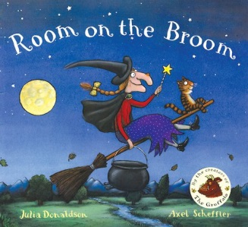
If you have any further questions you would like to discuss please don't hesitate to contact me on j.prince@percyhedley.org.uk
Thank you
Jess, Shauna, Ashleigh and the team.

