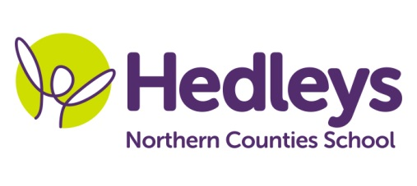
Spring Newsletter 2018-19

Dear Parents and Carers,
Welcome back - we hope everyone had a lovely Easter and didn’t eat too much chocolate!!!!
This term our team will stay the same other than sadly Becky leaving us. She has been given a fantastic new job opportunity and we wish her well in her new adventure.
This term the class topic will be Parks and Gardens
We will focus on the following areas of learning:
- Literacy – reading The Secret Garden
- Numeracy – focus on time and money
- Science – biology plants and animals
- Geography – local study of parks and gardens
- Computing – Designing their own park using a computer package
- PSHE – Body changes and puberty

In speech and language therapy sessions we will be continuing to consolidate writing in English word order throughout all sessions as well as learning how to get the metro in smiLE.
In occupational therapy sessions we will continue developing our fine motor skills and recognising our emotions as well as learning about road safety and stranger danger.
Please don’t hesitate to contact us at school on 0191 2815821 or
Helen – h.blakelock@percyhedley.org.uk
Poppy – p.welsh@percyhedley.org.uk
Julie – j.osborne@percyhedley.org.uk

Best wishes,
Helen and the team

