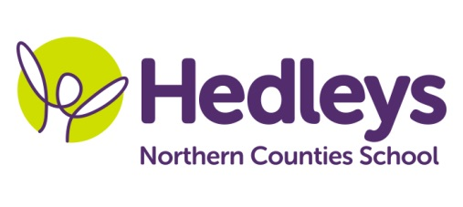
Spring Newsletter 2018-19

Dear Parents and Carers,

Welcome back, I hope everyone had a lovely Easter. This term our team is led by Abi Cowie (Assistant Head teacher – ASD), with the rest of the team of support staff remaining the same. Louise Allport and Shauna Garrity will remain as our class therapists and will continue to work in a fully integrated way into the team. This term the class topic will be ‘Sensational Stories’, focusing on Alice in Wonderland. We are planning to launch the topic, by visiting the new Alice in Wonderland woodland walk at Beamish Hall.

We will focus on the following areas of learning: Communication will be Interactive Stories and requesting a range of resources and equipment, learning new vocabulary and using in a range of contexts. In Maths, we will be exploring and learning about the concept of time, complete some work on shape and space and focus on directional language. In Food Technology, we will be making a range of afternoon ‘Alice’ inspired tea items, such as jam tarts, pizzas and sandwiches. Art will be looking at the way the story of Alice is interpreted through a range of art and pupils will be making model croquet mallets, giant mushrooms and will get to design and make their own chair. In Science, pupils will learn more about the structure of the earth and the rock cycle. R.E. lessons are based upon the principles and stories of Buddhism - we are hoping to visit the Buddhist temple later on in the summer term.

Please don’t hesitate to contact me if you would like any further information, or a chat about pupil progress. There will also be lots of updates each week on Earwig Academic Timelines, where you can view photographs of your child engaging in their school day. You should be receiving emails to notify you when new photographs have been uploaded, if not please let me know.

Best wishes,
Abi Cowie and the Hillcrest team
alee@percyhedley.org.uk

