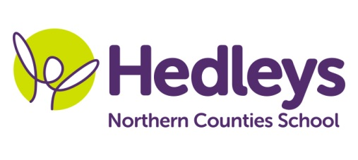
Winter Newsletter 2018-19

Dear Parents and Carers,
Welcome back, we hope you had a lovely Christmas break and that the children have had a well-deserved rest. We are really looking forward to getting back to work with them all this term.
This year our team is Ruth, Rebecca, Angela, Donna, Kelly, Kirsty, Kadiza, Tracy, Asia and Nicola.
This term the class topic will be ‘Popular Culture’ with a particular focus on children’s TV programmes and game shows. Communication will focus on popular children’s’ texts which focus on the essence of teamwork
We will focus on the following areas of learning:
- Literacy work will be based on team work and include work on the book ‘The Little Red Hen’.
- We will continue with visits into the community to transfer the communication and numeracy work we are doing in school.
- In line with the theme of TV gameshows, the children will have a weekly session accessing soft play in Newcastle’s city centre.
- Science sessions this term will be based around the topic of electricity.
- Art tasks will take inspiration from TV game shows, where some will involve encouraging the use of gross motor skills and messy play!
- RE and food technology will merge as one session where ‘special foods’ will be created by the pupils.
The occupational therapist will be working on further development of student's self-care and independence skills which will be promoted throughout the school day. During sensory integration sessions, students will have opportunities to access a number of activities relevant to their individual sensory needs supporting the ability of emotional regulation necessary for learning. This term students will also have regular opportunities to interact with the magic carpet which constitutes a fantastic resource promoting the development of a child's most meaningful occupations, including playing, learning, and socializing. Integrated work will continue to facilitate achievement of individualised child-centred goals.

Please don’t hesitate to contact us on r.gillet@percyhedley.org.uk (Rebecca) or r.woodford@percyhedley.org.uk (Ruth)
Best wishes,
Ruth & Rebecca (Class teachers)

