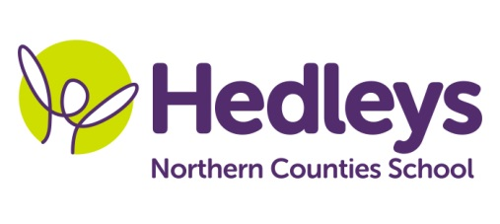
Autumn Newsletter 2018-19

Dear Parents and Carers,
Welcome back to school after the summer holiday – we have got a busy term planned! This year our team is made up of mostly familiar faces; Sharon, Amy, Linda, Sue and Julie will continue to work one to one with the students and I will also have support from Kim Dobson (higher level special support assistant). The therapy team also remains the same and Ashleigh Richardson (formerly Laidlaw) will continue as SaLT, Michele McCafferty as OT and Gemma James as physiotherapist.
This term the class topic will be “schools” and we will be thinking about school routines and different school based activities. All physical sessions and movement activities will continue as they did last year.
We will focus on the following areas of learning:
- Individual communication strategies.
- Working together to build relationships between students through shared games and intensive interaction.
- Developing and maintaining physical skills to enable the students to explore different movement patterns and optimise function.
In speech and language therapy sessions we will continue to work on developing the students’ receptive and expressive communication skills using a total communication approach. This includes but is not limited to the use of BSL signs, TaSSeLs signs, a core vocabulary of symbols to develop choice making, use of technology to further develop cause and effect skills and principles of intensive interaction to enable students to build and maintain relationships with adults and peers around them. All programmes will be overseen by speech and language therapy and incorporated throughout the timetable.
In occupational therapy sessions we will continue to assess students for high and low tech equipment such as the eye gaze and using the eye transfer frame in collaboration with Ashleigh. Gemma and Michele are going to continue to work together to ensure every student has a postural management assessment to inform future postural management and seating assessments. Hand function sessions will continue for some students with a focus on grasp and release in time to music and games.
In physiotherapy sessions we will continue to work on developing and maintaining motor skills in a range of positions and contexts. Physiotherapy will be integrated into the timetable to enable students to access this throughout the day, and programmes will continue to be individualised to the needs of the student. We will continue to work closely with occupational therapy, to promote postural management and optimise functional independence, at both school and in the home environment.
Please do get in touch if you have any queries or questions via the home/school diary, phone, e mail (r.field@percyhedley.org.uk) or by popping into school. I am looking forward to a fantastic term working with your young people!
Best wishes, Ros Field

