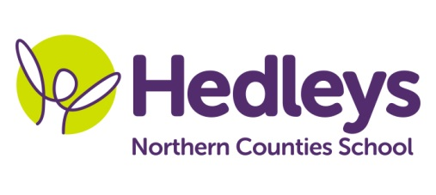
Autumn Newsletter 2018-19

Dear Parents and Carers,
We hope you all had a lovely summer holiday and everyone is ready for a busy term. We now have a class of six young people and while we do come together for group sessions we are utilising a number of classrooms and therapy spaces.
This year our team consists of myself and Julia Patterson, with Julie Lowdon as our HLSSA and SSAs Jacqui Allen, Amanda Lee, Inna Lowes, Jill Nielson, Amy Jordan and Sarah Turner.
This term the class topic will be “Hobbies and Interests”.
We will continue to focus on our communication, physical skills and sensory exploration, all of which remain integrated throughout all daily sessions.
In speech and language therapy sessions with Nicola Leonard/ Carra Lynn Lindsey we will enjoy a sensory story, build relationships with our new friends in social games, and work on EyeGaze and switching.
In occupational therapy and physio sessions with Michele McCafferty and Frances Slowie we will be developing and maintaining our physical skills, while working on our individual targets. Rebound and hydro or swimming will continue as last year (or as per discussions with yourselves)
Please don’t hesitate to contact us on:
r.jeffares@percyhedley.org.uk
j.lowdon@percyhedley.org.uk
j.patterson@percyhedley.org.uk
Best wishes,
Rachel and the class team

