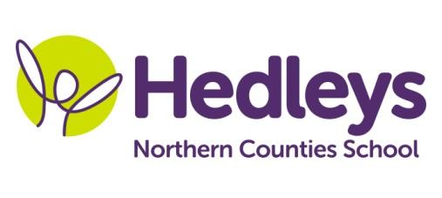
Autumn Newsletter 2018-19
Dear Parents and Carers,
It was lovely to see all the pupils back after the summer holidays and hear all about what they have been up to during the summer break. All the pupils have settled in quickly and have made a great start to our new curriculum topic.
This year joining myself and our brilliant higher level special support assistant Evie we have Richard, Lois, Josh, Lauren, Claire and Jane who continue working within the class as special support assistants from last year. Joining our team we have Beth and Debbie. Louise continues to provide our speech and language input and Shauna continues to deliver our occupational therapy sessions. Kerry will continue to deliver our swimming sessions and will take over our P.E. curriculum. Pamela continues leading our music sessions and Zoe will continue delivering our mobility program for our VI students.
This term the class topic will be Fantastical Forests. During our topic, we will focus on the following areas of learning:
- In morning routine we will focus on letter and number identification, ordering and writing. We will be working on numbers up to 20 and the letters in our names and the days of the week.
- In communication we will be learning about the stories and illustrations of a range of books including The Stickman, We’re Going on a Bear Hunt and Where the Wild Things Are.
- In maths we will be focussing on measurement using standard and non-standard units of measurement to identify the length, height, width and capacity of different forest materials.
- In art we will be taking inspiration from Andy Goldsworthy the artist who collaborates with nature to make his creations, to produce a range of forest themed artworks.
- In science we will be identifying and naming a range of wild and garden plants alongside identifying the structures of these plants. We will also identify a variety of common animals
- We will continue to participate in a range of community based activities including numeracy and communication in the community, shopping for items to use in our food technology sessions and visiting a local cafe to use communication and money skills learned in class in a functional setting. We will visit a range of local landmarks in our humanities sessions and we will be building a basic map based on the places we have visited.

In speech and language therapy sessions we will continue to practise the skills required to develop functional communication and also encourage opportunities in a range of situations and activities to use those skills. We will use vocabulary linked to the fantastical forest theme as well as working on core vocabulary to use in everyday situations. In our communication sessions, Louise and Peter will demonstrate strategies for the staff team to practice and additional sessions will provided to focus on individual IEP targets. We monitor these strategies individually with all students in a variety of functional activities. The therapy team and class staff continue to work very closely together to ensure that communication strategies are used across the curriculum however our focus this term is to ensure that students are able to use their communication effectively during learning breaks and times of transition.
In occupational therapy sessions we will continue to have opportunities to engage in lots of sensory based tasks. As part of our forest theme this term, we will be exploring We’re Going on a Bear Hunt sensory story in our communication group. Within our communication in the community sessions we will be accessing cafés in the local area as part of our smiLE programme, which focuses on developing appropriate social skills within daily living tasks. We will also continue to develop our abilities to carry out activities of daily living as independently as possible such as our showering routines as part of our life skills programme. A range of both individual occupational therapy sessions with Shauna and joint therapy sessions with Louise will be accessed throughout this term by all students, in order to meet individual IEP targets.
Please contact us using the following email p.stephenson@percyhedley.org.uk or call 0191 281 5821
Best wishes,
Peter Stephenson

